Illinois Mental Health Collaborative
Provider
Guide to
IntelligenceConnect
For Reporting
January 14, 2009

www.illinoismentalhealthcollaborative.com

IntelligenceConnect allows providers/submitters to access reports and data sets directly from the Collaborative’s claims processing system through our website. This feature does not require special software.

If you have questions or need technical guidance, contact the e-Support Helpdesk at 888-247-9311, Monday through Friday, 8am – 6pm EST. You may also email the Helpdesk directly at
e-supportservices@valueoptions.com

Please direct any questions regarding claim status, payment or rejection to the Claims Customer Service Department at 866-359-7953.

Instructions for IntelligenceConnect

Agencies must have an electronic account established with the Collaborative to run and review reports. If an agency does not currently have an electronic account, register online at www.illinoismentalhealthcollaborative.com or contact the e-Support Helpdesk at (888) 247-9311 for assistance. The required Account Request Form to establish an account can be downloaded from the Collaborative’s website (click on For Providers, then ProviderConnect Helpful Resources, then Forms on the left side of the page) or can be obtained by contacting the e-Support Helpdesk.

Once an account is set up:
- Access http://www.illinoismentalhealthcollaborative.com and click on the For Providers link. This will display the Provider Online Services Home Page.
- Click on Log In, which displays the ProviderConnect Log In page. Enter your User ID (Submitter ID) and password.
- After logging in, select “Yes” at the User Agreement screen before proceeding.
- The Welcome page now displays with the related menu options displayed on the left side of the screen.
- To run a report, click on the “Reports” button on the left.

Illinois Collaborative Claim Reports (Not all of the reports listed below are currently available; the Collaborative will send an Email Alert as reports become available.)

- EDI Batch Claims by Batch Submission #
- EDI Batch Claims by Batch Submission Date
- EDI Batch Claims Submitted by Submitter ID
- Claims in Process by Submission Date
- Denied Claim Lines by Submission Date
- Denied Claim Lines by Submission Date – Fund Source
- Denied Claim Lines by Submission Date – Consumer Name
- Approved Claims by Submission Date
- Staff ID Activity Submitted by Service Date
- Provider Claims Detail Data Set

Eligibility Reports –

- Il Consumer Registrations for Specific Consumer
- Il Consumer Expiring Registration by Submitter ID/RIN
- Il Consumer Expiring Registration by Submitter ID/Client ID
- Il Consumer Expiring Registration by RIN
- Il Consumer Expiring Registration by Client ID
- Il Consumer Expiring Registration by Submitter ID/RIN
- Il Consumer Expiring Registration by Date of Expiration
- Il Consumer Registrations Entered for Date Range by Submitter ID/RIN
- Il Consumer Registrations Entered for Date Range by Submitter ID/CLIENT ID
- Il Consumer Registrations Entered for Date Range by RIN
- Il Consumer Registrations Entered for Date Range by Client ID
- Il Consumer Registrations Entered for Date Range by Last Name
- Il Consumer Registrations Entered for Date Range by Date Entered

- Il Expired Consumer Registrations by Submitter ID/RIN
- Il Expired Consumer Registrations by Submitter ID/Client ID
- Il Expired Consumer Registrations by RIN
- Il Expired Consumer Registrations by Client ID
- Il Expired Consumer Registrations by Last Name
- Il Expired Consumer Registrations by Expiration Date

- Il Active Consumer Registrations by Submitter ID/RIN
- Il Active Consumer Registrations by Submitter ID/Client ID
- Il Active Consumer Registrations by RIN
- Il Active Consumer Registrations by Client ID
- Il Active Consumer Registrations by Last Name

- Il Closed Consumer Registrations by Submitter ID/RIN
- Il Closed Consumer Registrations by Submitter ID/Client ID
- Il Closed Consumer Registrations by RIN
- Il Closed Consumer Registrations by Client ID
- Il Closed Consumer Registrations by Last Name
- Il Closed Consumer Registrations by Closed Date

Registration Data Set

- Il Consumer Registration Enrollment Data Set by Registration Start Date
- Il Consumer Registration Enrollment Data Set by Registration Entered Date
- Il Consumer Registration Clinical Data Set by Registration Start Date
- Il Consumer Registration Clinical Data Set by Registration Entered Date

Step 1: Security Certificate:

Click ‘Yes’

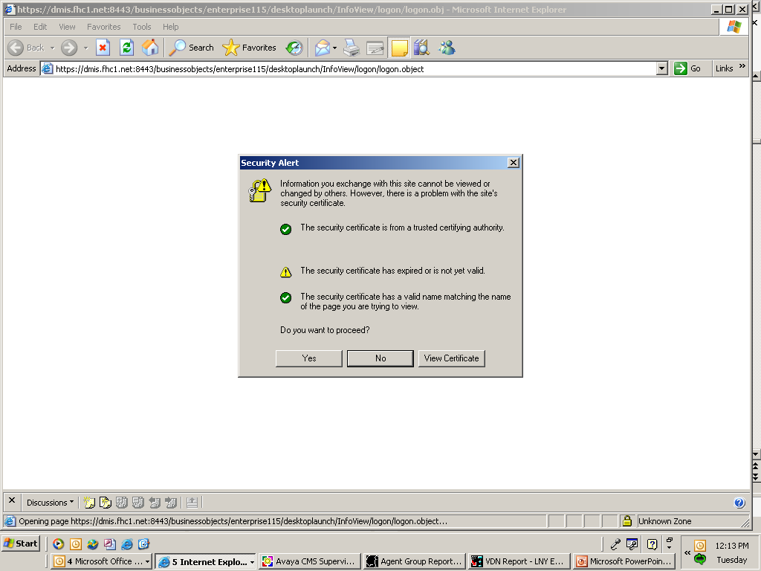

Step 2: Secure and Non-Secure information:

Click ‘Yes’

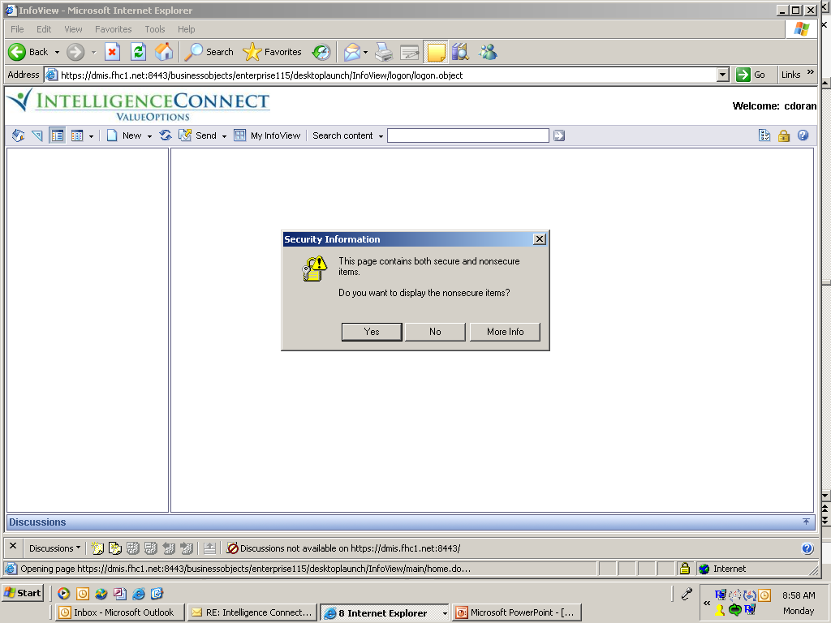

Step 3:IntelligenceConnect Screen

Select ILL Provider Connect

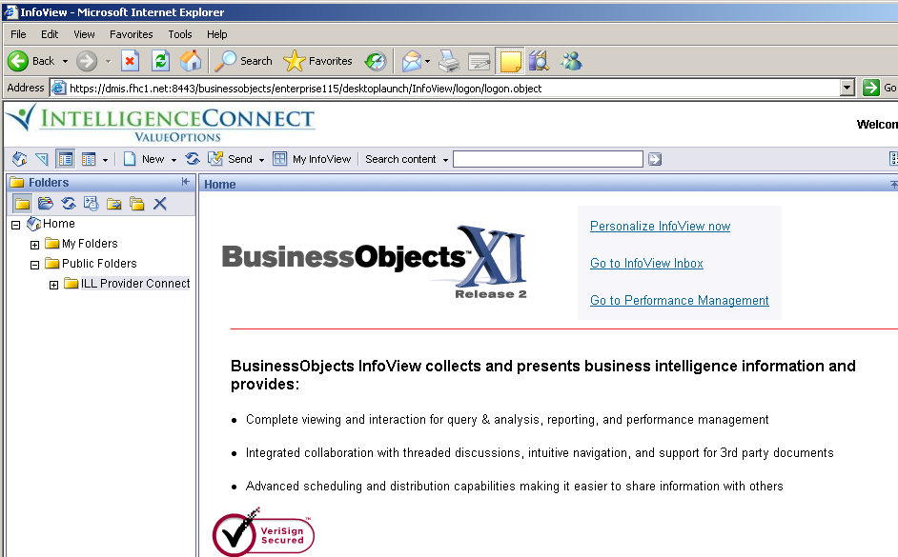
Step 4: List of available reports/data set

All available reports display on-screen. To choose a report, click on ‘Schedule” under the report name.

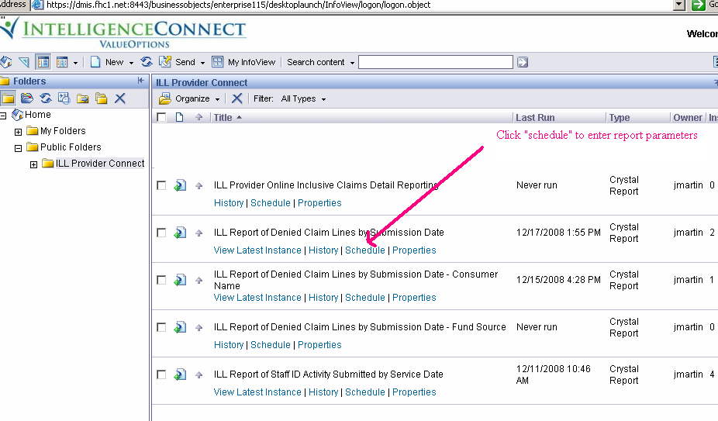

Step 5: Running Report/Data Set

Click on (+) next to Parameters, this will open the list of parameters for the report selected. Go through each parameter and fill-in/select appropriate value.

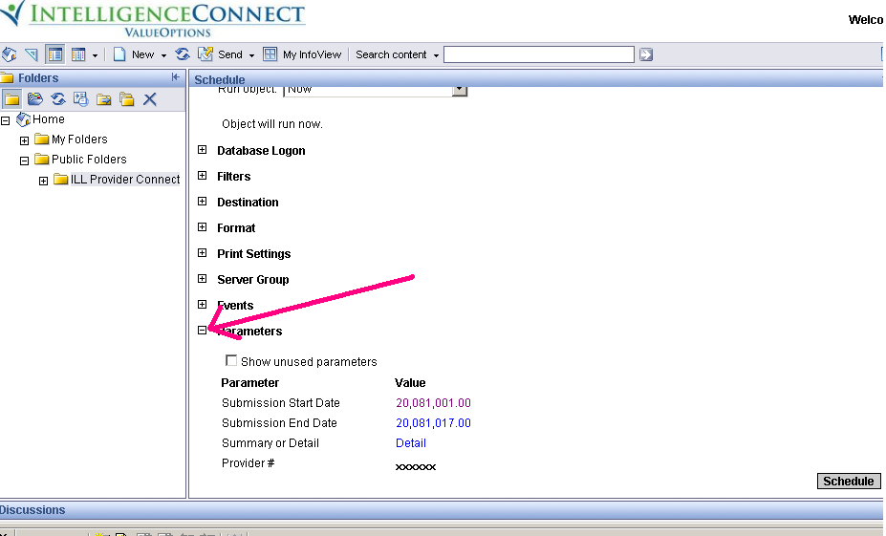

Step 6: Selecting Parameters

Click on first parameter to set. The Submission Date has been chosen below. Enter date as it is shown in the example (YYYYMMDD). Enter the date then click ‘OK’

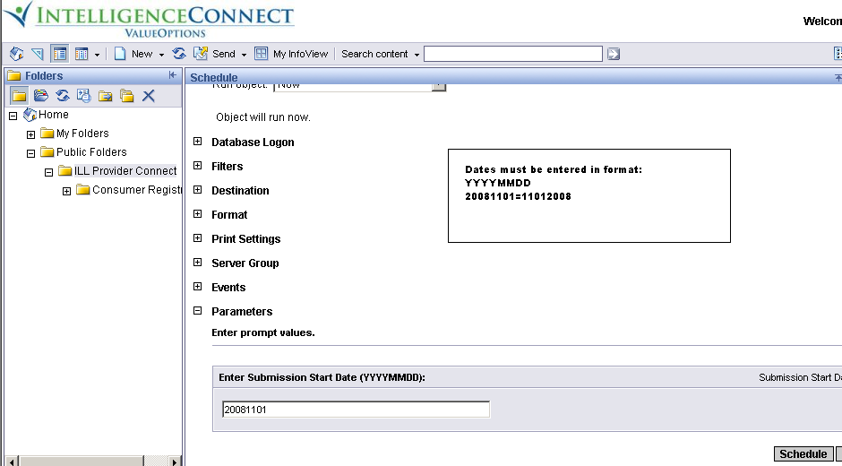

For parameters asking for a (Provider) or ID number (staff ID, consumer ID) insert an (*) for all, or input a single ID number. Enter the (*) or provider number in the box on the left and then add it to the box on the right by clicking on the (>), if you enter the number incorrectly or want to remove it, highlight the item to be removed and click on the remove button. Once you are satisfied with what you have entered click “OK”

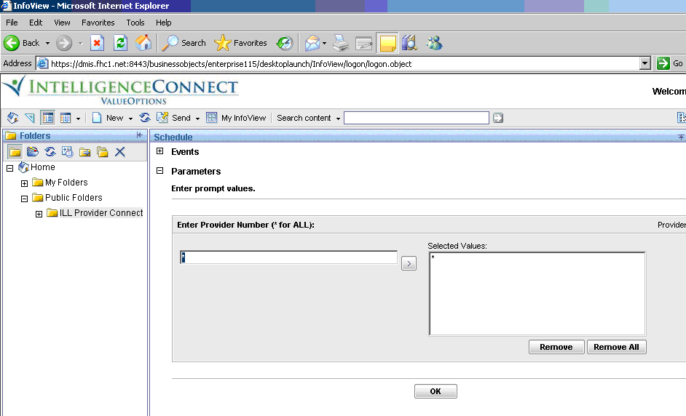

Step 7: Submitting Report

Once all parameters have been selected, the report can be scheduled.

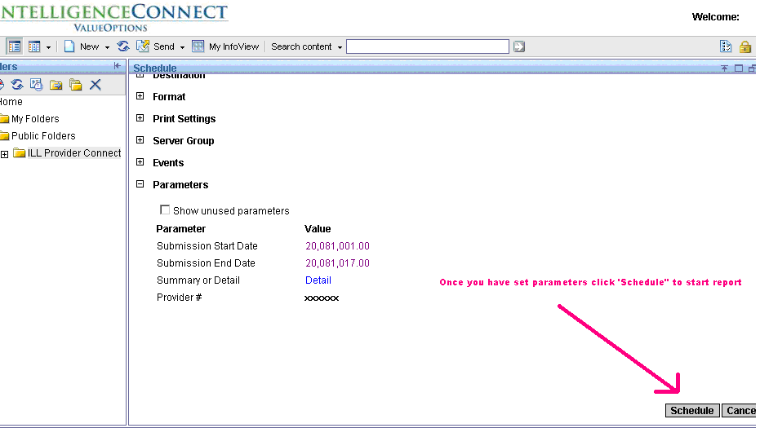

Click

After the report has been scheduled, it can be seen at the top of the list. ‘Pending’ indicates the report is gathering the data requested.

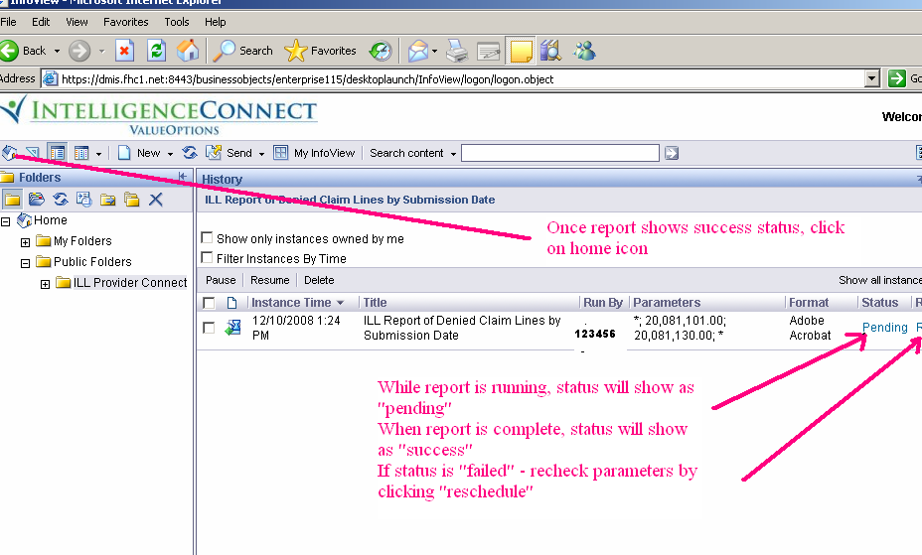

Step 8: Viewing the report

To view the report, click on the “Home” icon in the upper left corner.
This will bring you back to the Home Page; click on ‘Go to InfoView Inbox’ on the right side of the screen

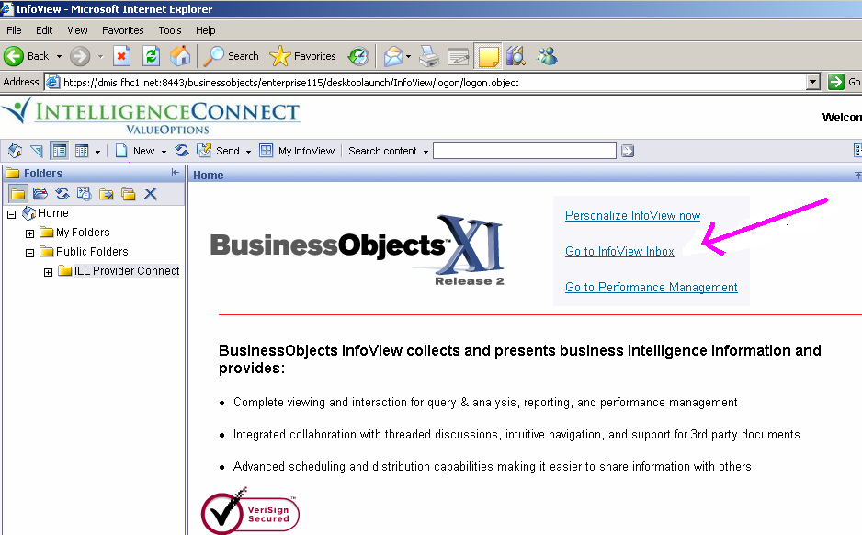

Step 9: Viewing Report

Once InfoView has been accessed, all reports will be displayed. To view/print the reports, click on the name of the associated report.

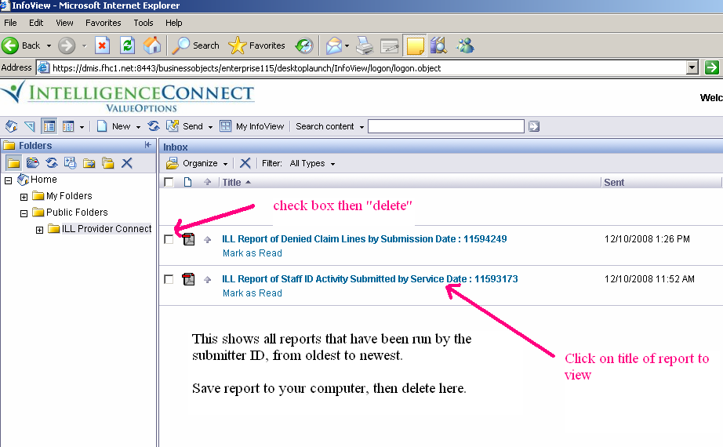

This will bring up the actual report. It may now be printed or saved your report. To print your report click on the print icon, to save your report click on the save icon and save it on your local drive.

You may now click on the ILL Provider Connect folder and run a new report if needed

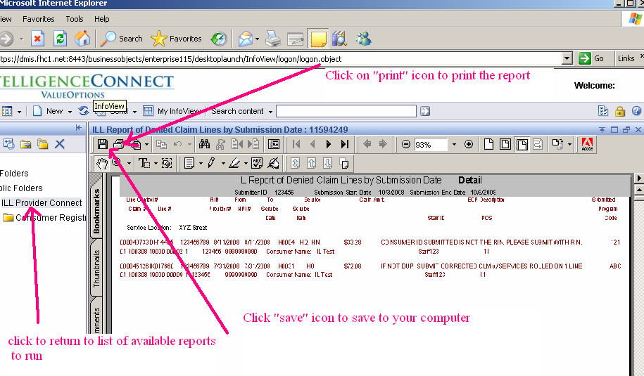

If you have any questions, or need technical guidance, contact the e-Support Helpdesk at 888-247-9311, Monday through Friday, 8am – 6pm EST. You may also email the Helpdesk directly at e-supportservices@valueoptions.com

Please direct any questions regarding claim status, or payment or denial questions to the Claims Customer Service Department at 866-359-7953

Data Dictionary Claims
 | Definition
835 | HIPAA 835 Health Care Claim Payment/Advice This transaction set can be used to make a payment, send an Explanation of Benefits (EOB) remittance advice, or make a payment and send an EOB remittance advice only from a health insurer to a health care provider either directly or via a financial institution
837 | Transaction set in standard EDI HIPAA format. The only accepted electronic format for a professional (837P) CMS 1500 or intuitional (837I) UB as mandated by HIPAA
# clients in Group | For group based services the number of clients in the group as sent by the provider in line notes
# staff in group | For group based services the number of staff in the group as sent by the provider in line notes
Activity Code | The W code that accompanied service code S9986 in the line note on batch submitted claims
Adjudicated Program Code | Program Code that was assigned to the service during claims adjudication
Allowed Amount | The fee schedule allowance for a service
Batch claims | Claims submitted via EDI process
Batch Submission # | Number the Collaborative sent to submitter via email after successful batch submission
Billing Location | The location that is billing for services rendered
Charge | The amount that a provider charges for a service
Claim Line | Used to denote when multiple service lines are submitted on a claim, ie 01,02 etc
Claim Number | The Collaborative assigned number received upon submission/upload of the claim
Consumer | The person to whom services were rendered
Corrected Claim | A claim submitted to 'correct' a previously submitted claims, i.e. for incorrect DOS, charge amount, etc.
CPT | Current Procedural Terminology- listing of descriptive terms and identifying codes for reporting medical services and procedures providing a uniform language that accurately describes medical, surgical, psychiatric and diagnostic services
DCN | Provider configured ID number for the claim
Delivery Mode | Either face to face (F), video (V), telephonic (T), or not applicable (N) as submitted by provider in line note
DOS | Date the service was performed
Duration | Length of time the session lasted as submitted by provider in line note
ECLW | EDI Claim Link for Windows - Software program the Collaborative offers to submit HIPAA compliant files
EDI | Electronic Data Interchange
Finalized | Claims that have gone through adjudication and check finalization
Group ID | For group based services, the group ID as assigned by the provider and submitted in the line note
HCPCS | Healthcare Common Procedure Coding System-Codes service are billed to the Collaborative using HCPCS codes
HIPAA | Health Insurance Portability and Accountability Act of 1996
In Process | Claim is "pended" for processor intervention before adjudicating
Legacy Number | Provider or Vendor number
Line Item Control # | Optional control number submitted by provider
Line Number | This number is assigned when there are multiple lines on a claim. i.e. 1,2,3, etc.
Modifiers | 2 character code that provides additional information regarding the service or item identified by the HCPCS code
NPI | National Provider Identifier - mandated for all HIPAA covered transactions as of May 23,2008
OHI Paid | If there is other health insurance coverage, the amount paid by that coverage
Paid amount | Dollars paid by the Collaborative
Paid date | The date the claim went through a payment cycle and finalized. It does not indicate that dollars were necessarily paid
Patient Account # | Optional patient identifier as submitted by provider
Pay To Location | The location to which payment for services should be sent
POS | The location that the service was performed, i.e. office
Pre-paid amount | The amount approved to apply against pre-payment amount
Provider Number | The number assigned by the Collaborative to distinguish an Agency
ProviderConnect | The weblink offered to providers to view and or submit eligibility, authorizations, claims information. Through this portal you can also submit eligibility, authorizations, claims information
Remark Code 1, Remark Code 2, Remark Code 3, Remark Code 4 | The messages that will appear on Provider Voucher to explain how a claim adjudicated
Replacement Claim | A claim submitted to 'replace' a previously submitted claims, i.e. for different Consumer
Service Code | HCPCS or CPT used to define service rendered
Service Location | The location in which the service was rendered
Staff ID | Staff ID as assigned by provider in line notes
Staff Qualification Indicator | 2 character code that provides additional information regarding the staff qualification of provider rendering service
Start Time | Start time of the session as submitted by provider in line note (Military Time)
Status | The part of adjudication that the claim is in: O = In process. P = Finalized, A = In Process
Subcontractor FEIN | The Federal Employer Identification Number of the entity to which services were subcontracted
Subcontractor NPI | The NPI of the entity to which services were subcontracted
Submission | Claims submitted via EDI process
Submission Date | The date the batch was sent to the Collaborative
Submitted Program Code | Program Code submitted on the claim
Submitter ID | Collaborative designated identification number for Agency representatives utilizing Providerconnect
Vendor Number | The number assigned by the Collaborative to distinguish an Agency

Enrollment Data Set Dictionary

IL Consumer Registration Data Download | Description
Registration Number | Unique number assigned by the Collaborative for this registration
Registration Date | Start Date of this registration period for the Consumer
Consumer ID (Recipient RIN) | The consumer’s recipient identification number (RIN)
Last Name | The consumer’s legal last name
First Name | The consumer’s legal first name
Middle Initial | Middle initial of the consumer
Name Suffix | The name suffix if the consumer has one (Jr, Sr, III, etc)
Birth Date | The date on which the consumer was born
Social Security Number | The consumer’s SSN
Mother’s Maiden Name | The maiden name of the consumer's Mother
Gender | Gender of the consumer
Client ID | A unique ID number assigned by the agency to the consumer
Agency FEIN | The agency’s nine digit Federal Employer Identification Number (FEIN)
Satellite Code | This code is assigned by DHS for the agency
Medicaid Site ID | HFS assigned Medicaid site ID number where the consumer is registered
Primary Address | The current street address of the consumer
Address Line 2 | The current street line 2 address of the consumer
City | The current City of the consumer
State | The current State of the consumer
Zip Code | The current Postal zip code of the consumer
County | The Illinois county code where the consumer currently lives (or out-of-state/unknown code)
Township/Community Area | The Community Area if the consumer resides in Chicago or Township if the consumer resides outside the Chicago city limits as applicable, where the consumer currently lives
Household Income | The total monthly income of all family members in the consumer’s household
Client Income | The total monthly income of consumer
Family Household Size | The total number of persons in consumer’s household, including the consumer
Household Composite | The consumer’s household composition
Education Level | The highest grade level completed by the consumer
Military Status | The military status of the consumer
Marital Status | Marital status of the consumer
Employment Status | The current employment status of the consumer
SSI-SSDI Eligibility | The Supplemental Security Income (SSI) and Social Security Disability Insurance (SSDI) eligibility status for the consumer
DFI-CFI Enrollment | The consumer’s Donated Funds Initiative (DFI) or Contracted Funds Initiative (CFI) enrollment status
Court / Forensic Treatment | Status of forensic/court-ordered treatment plans at the time of registration
Race #1 | Race of consumer
Race #2 | Race of consumer
Race #3 | Race of consumer
Race #4 | Race of consumer
Race #5 | Race of consumer
Hispanic Origin | Hispanic origin of a person of Spanish culture or origin, regardless of race
Language | Primary language of the consumer
Citizenship | The citizenship status of the consumer
Interpreter Services Needed | The type of interpreter services required by the consumer
MH Residential Indicator | Designates whether the consumer is enrolled in the DHS funded MH Residential program
MH Residential Arrangement | The consumer’s primary residential situation while services are being provided
Justice System Involvement | The consumer’s criminal justice system involvement at the time of case registration
Disaster Guest Type | Indicates the Disaster that brought the consumer to Illinois
Disaster Guest State | The Post Office abbreviation for the consumer’s home state if he/she is an Illinois guest due to a disaster
Disaster County | The FIPS county Code where the consumer lived in their state
Consumer third party payor? | Indicates if the consumer has other insurance, commercial or Medicare
Special Program Enrollment Juvenile Justice Program | Indicates the consumer is being registered for the Juvenile Justice Program
Special Program Enrollment PATH Grants | Indicates the consumer is being registered for the PATH Grants Program
Special Program Enrollment Comm Hosp Inpatient (CHIPS) | Indicates the consumer is being registered for the CHIPS Program
Special Program Enrollment Residential | Indicates the consumer is being registered for the residential program funded by DMH and operated by the registering provider
Residential level of care | Indicates the level of care in the residential program
Juvenile Justice Begin Date | This is the original date the consumer is registered for this program. This should not change when re-registering the consumer for the program.
Juvenile Justice End Date | The date the consumer is no longer receiving services under the Juvenile Justice Program
Path Grant Begin Date | This is the original date the consumer is registered for this program. This should not change when re-registering the consumer for the program.
Path Grant End Date | The date the consumer is no longer receiving services under the Juvenile Justice Program
CHIPS Begin Date | This is the original date the consumer is registered for this program. This should not change when re-registering the consumer for the program.
CHIPS End Date | The date the consumer is no longer receiving services under the Juvenile Justice Program
Consumer Residential Program Begin Date | This is the original date the consumer is registered for this program. This should not change when re-registering the consumer for the program.
Consumer Residential Program End Date | The date the consumer is no longer receiving services under the Juvenile Justice Program
Guardian 1 Type | Describes the relationship of the guardian or responsible person to the consumer
Guardian 1 First Name | The first name of the guardian or responsible person
Guardian 1 Middle Initial | Middle initial of the guardian or responsible person
Guardian 1 Last Name | The last name of the guardian or responsible person
Guardian 1 Address | Street or box number of the guardian or responsible person
Guardian 1 City | City of the guardian or responsible person
Guardian 1 State | Post Office abbreviation for State of the guardian or responsible person
Guardian 1 Zip Code | Postal zip code of the guardian or responsible person
Guardian 1 Zip Code Suffix | The last four positions of the zip code of the guardian or responsible person
Guardian 1 Appointment Date | The date of appointment as guardian by the court
Guardian 1 Termination Date | The date this guardian relationship to the consumer ended
Guardian 2 Type | Describes the relationship of the guardian or responsible person to the consumer
Guardian 2 First Name | The first name of the guardian or responsible person
Guardian 2 Middle Initial | Middle initial of the guardian or responsible person
Guardian 2 Last Name | The last name of the guardian or responsible person
Guardian 2 Address | Street or box number of the guardian or responsible person
Guardian 2 City | City of the guardian or responsible person
Guardian 2 State | Post Office abbreviation for State of the guardian or responsible person
Guardian 2 Zip Code | Postal zip code of the guardian or responsible person
Guardian 2 Zip Code Suffix | The last four positions of the zip code of the guardian or responsible person
Guardian 2 Appointment Date | The date of appointment as guardian by the court
Guardian 2 Termination Date | The date this guardian relationship to the consumer ended
MH Closing Date | The date that the agency terminated its commitment to provide services to the individual
MH Closing Disposition | The disposition of the consumer at the point he/she stops receiving services

Clinical Data Set Dictionary

IL Consumer Registration Data Download | Description
Registration Number | Unique number assigned by the Collaborative for this registration
Registration Date | Start Date of this registration period for the Consumer
Consumer ID (Recipient RIN) | The consumer’s recipient identification number (RIN).
Last Name | The consumer’s legal last name
Client First Name | The consumer’s legal first name
Client Middle Initial | Middle initial of the consumer
Name Suffix | The name suffix if the consumer has one (Jr, Sr, III, etc)
Birth Date | The date on which the consumer was born.
Gender | Gender of the consumer.
Client ID | A unique ID number assigned by the agency to the consumer.
MH Diagnosis Code Type | The manual used for reporting diagnosis codes for Axis I and II.
MH Axis 1 Diagnosis 1 | Valid Axis 1diagnosis code
MH Axis 1 Diagnosis 2 | Valid Axis 1diagnosis code
MH Axis 1 Diagnosis 3 | Valid Axis 1diagnosis code
MH Axis 2 Diagnosis 1 | Valid Axis 2 diagnosis code
MH Axis 2 Diagnosis 2 | Valid Axis 2 diagnosis code
MH Axis 2 Diagnosis 3 | Valid Axis 2 diagnosis code
MH Axis 3 Diagnosis 1 | Valid medical category
MH Axis 3 Diagnosis 2 | Valid medical category
MH Axis 3 Diagnosis 3 | Valid medical category
MH Principal Diagnosis Indicator | The consumer’s principal diagnosis for the focus of treatment.
Functional Scale Used | The functional scale used.
GAF/CGAS Score | Current functioning scale score as assessed in the registration process
CGAS - Self Care | Children and Adolescent Functioning assessment – Self Care
CGAS - Community | Children and Adolescent Functioning assessment – Community
CGAS - Social Relations | Children and Adolescent Functioning assessment – Social Relations
CGAS - Family Relations | Children and Adolescent Functioning assessment – Family Relations
CGAS- School | Children and Adolescent Functioning assessment – School
GAF-Social Group/School | Adult Functioning assessment – Social Group
GAF-Employment | Adult Functioning assessment – Employment
GAF-Financial | Adult Functioning assessment – Financial
GAF-Community Living | Adult Functioning assessment – Community Living
GAF-Supportive Social | Adult Functioning assessment – Supportive Social
GAF-Daily Living Activity | Adult Functioning assessment – Daily Living Activity
GAF-Inappropriate or Dangerous Behavior | Adult Functioning assessment – Inappropriate or Dangerous Behavior
GAF-Previous Functional Impairment | Adult Functioning assessment – Previous Functional Impairment
LOCUS - Risk of Harm | LOCUS Score – Risk of Harm
Recovery-Environment-Stressor | LOCUS Score – Recovery-Environment-Stressor
Recovery Environment-Supports | LOCUS Score – Recovery Environment-Supports
Functional Status | LOCUS Score – Functional Status
Co-Morbidity | LOCUS Score – Co-Morbidity
Recovery and Treatment History | LOCUS Score – Recovery and Treatment History
Acceptance and Engagement | LOCUS Score – Acceptance and Engagement
Composite Score | Total LOCUS composite score
Level of Care Recommended - Locus | The LOCUS recommended level of care for the consumer based on LOCUS composite score.
Level of Care Recommended - Assessors | The assessors recommended level of care for the consumer.
History of Illness - Continuous Treatment | Consumers History of Illness – Continuous Treatment
History of Illness - Continuous Residential | Consumers History of Illness – Continuous Residential
History of Illness - Multiple Residential | Consumers History of Illness – Multiple Residential
History of Illness - Outpatient | Consumers History of Illness – Outpatient
History of Illness - Previous Treatment | Consumers History of Illness – Previous Treatment
Co-Occurring Disorders | Indicates whether or not the consumer has been screened for co-occurring mental illness/substance abuse disorders
Evidence Based Practice - Supported Employment | Indicates if Evidence Based Practice – Supported Employment was used
Evidence Based Practice - IDDT | Indicates if Evidence Based Practice – IDDT was used
Evidence Based Practice - Medication Algorithm | Indicates if Evidence Based Practice – Medication Algorithm was used
MH Cross Disabilities Database -Form Completion Date | The date on which the MH cross disabilities database form was completed
MH Cross Disabilities Database -Primary Care Giver Age | The age of the primary care giver
MH Cross Disabilities Database -Type of Services Needed 1 | The type of services needed by the consumer as determined by the assessment staff
MH Cross Disabilities Database -Type of Services Sought 1 | The type of services sought by the consumer as determined by the consumer
MH Cross Disabilities Database -Type of services Needed 2 | The type of services needed by the consumer as determined by the assessment staff
MH Cross Disabilities Database -Type of Services Needed 3 | The type of services needed by the consumer as determined by the assessment staff
MH Cross Disabilities Database -Type of Services Sought 2 | The type of services sought by the consumer as determined by the consumer
MH Cross Disabilities Database -Type of Services Sought 3 | The type of services sought by the consumer as determined by the consumer
MH Cross Disabilities Database -Type of Services Needed Other Description | Describes the type of services when Other (90) is selected for Type of Services Needed
MH Cross Disabilities Database -Type of Services Sought Other Description | Describes the type of services when Other (90) is selected for Type of Services Sought
MH Closing Date | The date that the agency terminated its commitment to provide services to the individual
MH Closing Disposition | The disposition of the consumer at the point he/she stops receiving services
Functional Scale Used at Closing | If MH closing date not spaces this is required
GAF/CGAS Score at Closing | Current functioning scale score as assessed at the time of the case closing process

