Illinois Mental Health Collaborative
Provider
Guide to Using
Direct Claim Submission
www.illinoismentalhealthcollaborative.com

Direct Claim Submission allows the provider/submitter to enter claims directly into the Collaborative claims processing system through our website, without using any special software. Direct Claim Submission expedites both processing and payment of the claim.

If you have any questions, or need technical guidance, contact the e-Support Helpdesk at 888-247-9311, Monday through Friday, 8am – 6pm EST. You may also email the Helpdesk directly at e-supportservices@valueoptions.com

Please note, any questions regarding how a claim was processed (payment or denial questions) must be directed to the Claims Customer Service Department at 866-359-7953.

Instructions for Direct Claim Submission
You must have an electronic account established with the Collaborative to submit claims. If you do not currently have an electronic account, register online at www.illinoismentalhealthcollaborative.com, or contact the e-Support Helpdesk at (888) 247-9311 for assistance. Please note, a completed Account Request Form is required to establish an account. This form can be downloaded from the website (click on For Providers, then ProviderConnect Helpful Resources, then Forms on the left side of the page) or can be obtained by contacting the e-Support Helpdesk.

Once an account is set up, go to http://www.illinoismentalhealthcollaborative.com and click on the For Providers link. This will display the Provider Online Services Home Page.

Click on Log In, which displays the ProviderConnect Log In page. Enter your User ID (Submitter ID) and password.

After logging in, select “Yes” at the User Agreement screen before proceeding.

The Welcome page now displays. The menu options are displayed on the left side of the screen.

To enter a Direct Claim, click on the “Enter Claim” button.
Select the provider:
Choose which provider you are submitting this claim for

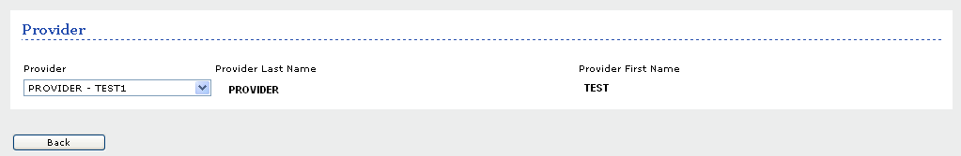

Verify the service location:
Click the radio button to indicate the correct combination of Service Location and Pay To address. (If the listed address options are incorrect or out of date, please contact our National Provider Line at 800-397-1630 to update your provider file)

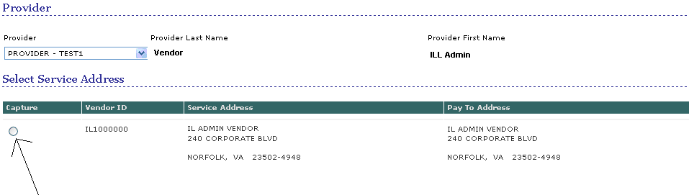

If necessary, a different provider may be selected at this point

Once the correct provider and service location information is selected, click “Next.”
Step 3: Verify NPI # and enter consumer information:
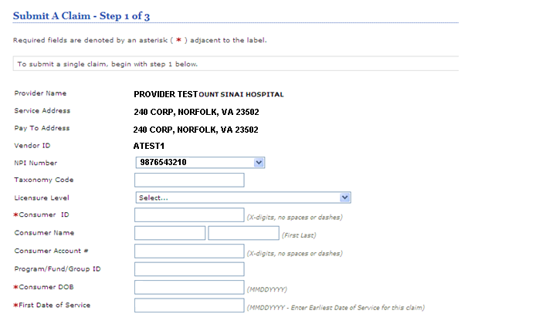

When entering a claim via Direct Claim Submission, the following fields are required for entry.
1. NPI Number: Select the correct NPI number for the provider on this claim. If this number is wrong or missing, contact our National Provider Line at 800-397-1630 to update your provider file.
2. Consumer ID: REQUIRED. This is the consumer’s RIN. Do not enter any spaces or special characters in this field. Only numbers and alpha characters are allowed.
3. Program/Fund/Group ID: REQUIRED. This is the Program Code for which you are submitting services.
4. Consumer DOB: REQUIRED. This is the consumer’s date of birth. It must be entered in MMDDYYYY format. Do not enter any dashes or slashes in this field.
5. First Date Of Service: REQUIRED. Enter the first date of service for this claim. It must be entered in MMDDYYYY format. Do not enter any dashes or slashes in this field.

Once all of the required information is entered, click “Next”. If the information is accurate, the Service Line Entry Screen will display.
If any information is inaccurate, an error message will appear in red at the top of the screen, and you can enter the correct information.

Step 4: Staff Level & Coordination of Benefit Entry
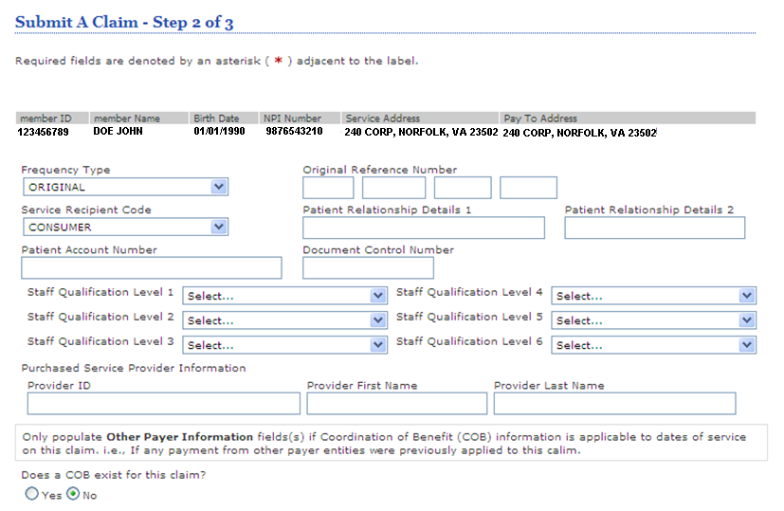

- Frequency Type –this is a drop down to select the type of claim being submitted- Original, Corrected, Replacement, or Void
  - If the Frequency Type is other than “Original,” an original reference (claim) number is required. – this is the Collaborative’s claim number from the original claim.
- Service Recipient Code defaults to “Consumer.” However if the recipient of services is other than the consumer, select either “Family” or “Collateral.” If Family or Collateral is selected, the patient relationship details should be completed.
- Patient Account Number is defined by the provider and is not required
- Document Control Number is defined by the provider and is not required
- Staff Qualification Level – this is a drop down to select the staff level rendering the services.
- Purchase Service Provider – if services were subcontracted to another agency, enter the FEIN of that agency here. Also enter the agency name in the Last Name field.

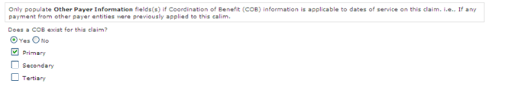
- Other Payer/COB Information:
- “Does a COB exist for this claim?”

  - Select ‘No’ if the consumer has no other health insurance that is applicable for this claim.
  - Select ‘Yes’if the consumer has other health insurance that is applicable to the services & dates of service rendered on this claim.
    - This will expand the section. Check the appropriate boxes as to whether the other coverage is primary, secondary or tertiary
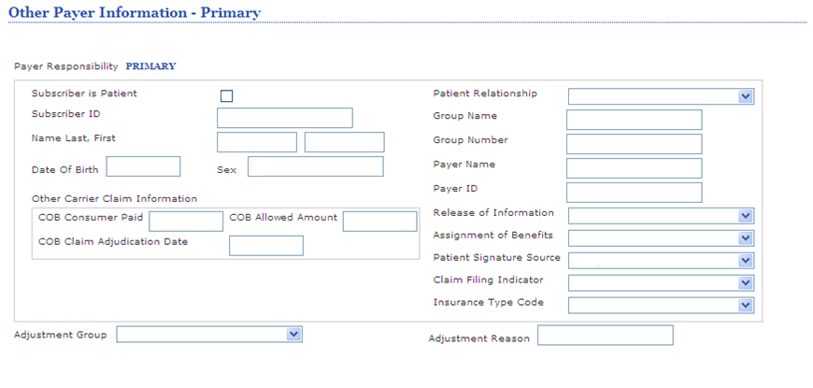
    - If the “Subscriber is Patient” field (this is the subscriber on the other coverage) is checked, all the consumer demographic information will fill.
    - If the subscriber on the other coverage is not the patient, do not check this field. Complete the demographic information for the other coverage subscriber.
    - COB Payer Paid – show the amount the other coverage paid for all the services on the claim.
    - Group Name – this is the name of the other insurance carrier i.e. Medicare B
    - Release of Information- this is a drop down, select the correct Release of information identifier
    - Assignment of Benefits- this is a drop down, select yes or no
    - Patient Signature Source- this is a drop down, the signature source
    - Claim Filing Indicator- this is a drop down, select the indicator that pertains to this insurance carrier
    - Insurance Type code- this is a drop down, select the indicator that pertains to this insurance type

Click “Next” at the far bottom of the screen to continue to the next page.
Step 5: Service Line Entry

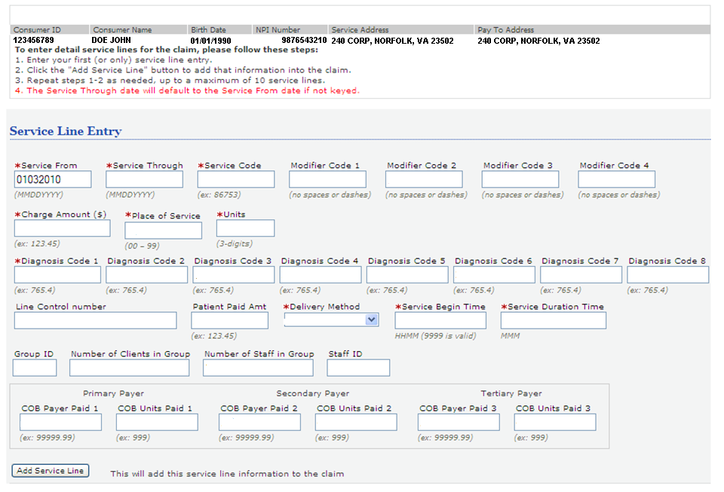

This is the claim detail page. The consumer information, service address, and pay to location will carry from information entered in Step 1. If the information is incorrect, click “Previous” at the bottom of the page to enter correct information.

The fields with an asterisk (*) are required.
- Enter the details for the first (or only) line of service for the claim.
- Click on “Add Service Line” to enter the information into the claim.
- Repeat 1 & 2 as needed, for a maximum of 10 service lines.

Please refer to the Illinois Mental Health Collaborative Service Matrix for the correct Service Code, sequence of Modifier Codes. Enter the charge amounts, units, and diagnosis code for the service.
Please note the following when completing these fields:
- All “date fields” must be entered in MMDDYYYY format, no slashes or dashes.
- Charge Amount: Do not include the dollar sign ($) in this field. (i.e.: 120.00, not $120.00)
- Enter the decimal in the “diagnosis code.”

Line Control number- is defined by the provider and is not required
Patient Paid Amount- enter this if the Consumer has paid any amount on this service
Deliver Method- chose from drop down- face to face, telephone or video
Service Begin time- in Military time, if bundling multiple same day services this will be 9999
Service Duration time- this is the amount of time used for this service, if bundling multiple same day services this will be the total time for all services
Group ID- the ID number defined by the provider for this service, if bundling multiple same day service this will be the first Group ID of the day
Number of Clients in group- the total number of clients in the group session, if bundling multiple same day services this will be the total number of clients in for all group services
Number of Providers in group- the total number of providers in the group session, if bundling multiple same day services this will be the total number of providers in for all group services

If you have also entered COB information as described in the previous step, you can also enter a distribution of those units and dollar amounts as it should be applied to individual service lines.
Step 6: Review Service Line Entries
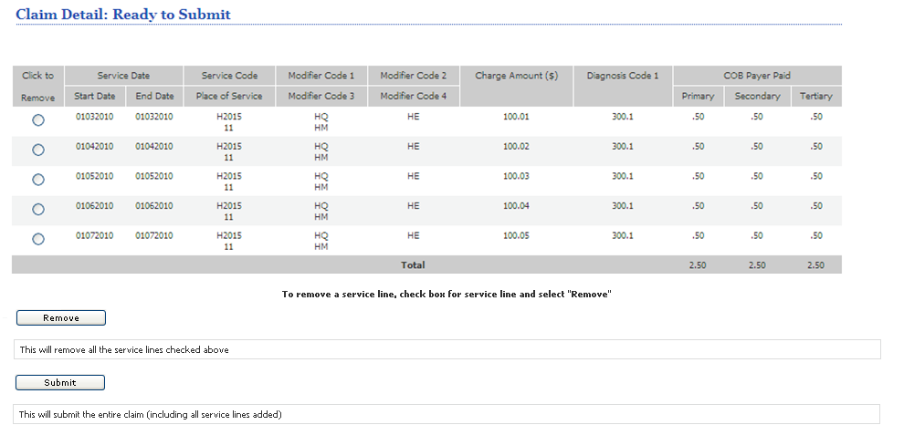

All of the service lines entered in the “Service Line Entry” section will appear in the “Claim Detail: Ready to Submit” section on the lower portion of the screen. This allows the opportunity to verify the data entered for the specific consumer is correct.

If a service line should be removed, click the “Check to Remove” button for that individual line – then press the “Remove” button. Repeat this process for any additional service lines that should be removed. Enter correct service lines by following the directions on the previous step.

Click the “Submit” button to submit the claim to the Collaborative.

Please note, once the “Submit” button is clicked, no further changes can be made to the claim. A corrected claim must be submitted. See Appendix 1 for instructions to submit a corrected claim.
Final Step: Summary Page

This is the submission results page. The “Claim #” shown is the information needed when inquiring on the status of this claim. Please contact the Claims Customer Service department with claim questions at 866-359-7953.

To enter a claim for another consumer press the “Enter New Claim” button at the bottom of this screen.

For additional detail on a submitted claim, click on the Claim Number, which displays the “Claim Search Results” page where more information is provided:

If the Claim Status reads “In Process,” the claim is still open, and is not yet finalized.

If the Claim Status reads “Processed”, click on the tab for “Service Line Detail” to display payment or denial information on the claim.

If you have any technical questions please contact the EDI Helpdesk at 888-247-9311 (M-F, 8am-6pm EST) for assistance.
Appendix 1: Submitting a corrected/replacement claim.

Submitting a corrected/replacement claim is essentially the same process as submitting an original claim, with only one small change.

- Obtain the claim number from your original claim, either from your summary page, or from a claim search. For this example, we will use the claim number: 01-070308-11111-99999

- Follow the instructions above for steps 1-3.
- On Step 4: Staff Level & Coordination of Benefit Entry, make the following entries:
- For “Frequency Type” select Corrected or Replacement
- In the “Original Reference Number” enter 01 in the first box, and enter the segments of the claim number in the remaining three boxes.
- Complete any other fields on this page as needed for the claim.
- Click Next, and continue from Step 5 above.

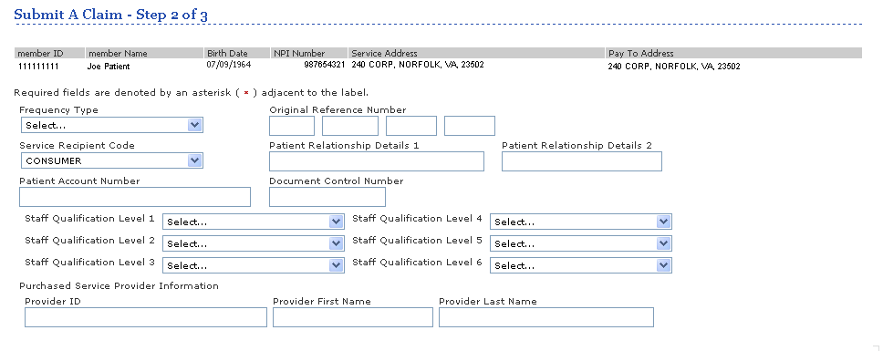

If you have any technical questions please contact the EDI Helpdesk at 888-247-9311 (M-F, 8am-6pm EST) for assistance.

