

Illinois Provider Batch Registration
File Specifications
Version 4.08
July 2014

TABLE OF CONTENTS

VERSION CHANGE LOG 3
INTRODUCTION 10
PURPOSE 10
TELECOMMUNICATIONS SPECIFICATIONS 10
GENERAL COMMENTS 10
PROVIDER REGISTRATION ELECTRONIC SUBMISSION FILE SPECIFICATIONS 11
INDICATOR ‘D’ – ADDRESS UPDATE ONLY 11
INDICATOR ‘C’ – CLOSE REGISTRATION OR SPECIAL PROGRAM END DATE 12
INDICATOR ‘R’ – REGISTRATION OR RE-REGISTRATION 13
BATCH SUBMISSION FILE LAYOUT 14
ERROR PROCESSING 62
SUBMITTING A BATCH REGISTRATION FILE 63
FILE ERRORS 70
RESPONSE FILES 71
Summary File 71
Accepted File 72
Error File 75
RETREIVING RESPONSE FILES 76

VERSION CHANGE LOG
Version 1.0 - Published June 24, 2008
Version 2.0 - Published September 17, 2008 – Added error processing, response files, telecommunications – email subject line
Version 2.1 – Published October 2, 2008
- Updated accepted file – Upload Status field to only be ‘O’
- Updated rejected file – Upload Status to only be ‘1’
- Clarified Income Level – is consumer’s monthly income
- Corrected Trailer record position 26 – 843 to be a length of 818
- Corrected MH Cross Disabilities Database-form completion date to MMDDYYYY
- Residential Level of Care – error message corrected
Version 2.2 – Published November 12, 2008
- Added error code 157 – error message – ‘Only one of the Social Security fields can be populated’
- Added error code 158 – error message - : ‘Child functioning levels should not be populated when GAF score is used.’
- Added error code 159 – error message - : ‘Adult functioning levels should not be populated when CGAS score is used.’
Version 3.0 – Published 01/22/09
- Removed value of ‘00’ – Not applicable from Type of services sought 1, 2 and 3

The changes listed here are being implemented 2/27/09. The last run of the current batch process will be 2/26/09 at 1 PM Central. Any files received after 1 PM will need to meet the new requirements. All files received after 1 PM will be held and processed after the changes have been implemented on 02/27/09 and the reports will be available on Monday, 03/02/09.
- Added new indicator (field position 25)
- Modified Error Code 154 to allow ICG registration during SASS period
- Added Address Update Only process
- Added new closing process
- Added additional error codes 160, 161, 168, 173 - 178
- Added error codes 164 – 167 and 169 – 172 to require end date for special programs
- Modified Axis 1 diagnosis codes 2 and 3, All axis 2 diagnosis codes and Axis 3 Diagnosis code 1 to be required
- Modified All Axis 3 diagnosis codes from ICD-9 codes to Medical Categories
Version 3.1 – Published 01/30/09
The following changes are being made to the February changes outlined in Version 3.0
- Axis 3 Diagnosis Code 1 will not be required
- All Axis 3 Diagnosis Codes will need to be ICD-9

Version 3.2 – Published 2/19/09
The changes listed here are being implemented 3/27/09. The last run of the current batch process will be 3/26/09 at 1 PM Central. Any files received after 1 PM will need to meet the new requirements. All files received after 1 PM will be held and processed after the changes have been implemented on 03/27/09 and the reports will be available on Monday, 03/30/09.

- Length of the file is changing from 844 to 868 to accommodate the following fields:

- Special Program ICG Community
- Special Program ICG Community Begin Date
- Special Program ICG Community End Date
- Adoption Indicator
- Columbia Scale
- Ohio Scale – Problem Severity
- Ohio Scale – Functioning

- Guardian 1 is required for ICG and ICG Community

- Error codes 134, 168, 174, 175 and 176 have been modified to include ICG Community

- New error codes 179 –185 and 187 - 191 for validation of new fields

- New error codes 182, 183 and 185 include all special programs

- Trailer Record filler changed from position 26 – 843 to 26 – 868
Version 3.3 – Published 2/27/09
- New value of Self was added to Guardian Type 1 and Guardian Type 2
Version 3.4 – Published 3/9/09
As of 3/27/09, change in length to the response files to add the new fields related to ICG.
Guardian Appointment required when Guardian Type is 05.

Version 3.5 – Published 4/24/09
As of 4/25/09 two new messages have been added to the accepted report

For the ABC fund the following message will appear: If the consumer requires ACT or CST services an authorization needs to be requested within 30 days.

For the ICG and ICGC fund the following message will appear: Any required Authorization/Quarterly Review must be submitted within 30 days.

Version 3.6 – Published 7/27/09

The changes listed here are being implemented 8/28/09. The last run of the current batch process will be 8/27/09 at 1 PM Central. Any files received after 1 PM will need to meet the new requirements. All files received after 1 PM will be held and processed after the changes have been implemented on 08/28/09 and the reports will be available on Monday, 08/31/09.

- Length of the file is changing from 868 to 871 to accommodate a new fields for income verification, Permanent Supported Housing and Money follows the Person.

- Added income verification field – position 869

- Added Permanent Supported Housing – position 870

- Added Money follows the Person – position 871

- Trailer Record filler changed from position 26 – 868 to 26 – 871

- Income verification, Permanent Supported Housing and Money follows the Person fields added to response files

- Diagnosis field errors updated to exclude submission of the decimal

- New error codes 193 – 197

- Updated error code 026
Version 3.7- Published 12/28/09
The changes listed here are being implemented 01/30/10. The last run of the current batch process will be 01/28/10 at 1 PM Central. Any files received after 1 PM will need to meet the new requirements. All files received after 1 PM will be held and processed after the changes have been implemented on 01/30/10 and the reports will be available on Monday 02/01/10.
- Length of the file is changing from 871 to 888 to accommodate new fields for CHP Indicator, CHP Begin Date, CHP End Date.

- Added CHP Indicator field- position 872

- Added CHP Begin Date field- positions 873-880

- Added CHP End Date field – positions 880-888

- Trailer Record filler changed from position 26-871 to 26-888

- CHP Indicator, CHP Begin Date and CHP End Date added to response files

- New error codes 198-207

Version 3.8 – Published 1/14/10

- Update to error code 207

- Added new closing disposition value: 09 - CHP – Administrative Closing

Version 3.9 – Published 2/4/10

- Correction to accepted filed positions for the following fields:
  - Program Code – position 891 – 894
  - Effective date – position 895 – 902
  - Expiration date – position 903 – 910
  - Comment – position 911 - 1010
Version 4.00 – Published 7/29/10

These enhancements will be implemented 9/17/10. The last run of the current batch process will be 9/16/10 at 1 PM Central. Any files received after 1 PM will need to meet the new requirements. All files received after 1 PM will be held and processed after the changes have been implemented on 0/17/10 and the reports will be available on Monday, 9/20/10.

- Length of the file is changing from 888 to 909 to accommodate new fields and changes to existing fields
  - Functional Scale Used is moving to position 889
  - GAF/CGAS Score is moving to positions 890 – 892 and is being expended to 3 positions – valid values for CGAS score – 1 – 100, valid values for GAF – 0 - 100
  - Functional Scale Used at closing is moving to position 893
  - GAF/CGAS Score is moving to positions 894 – 896 and is being expended to 3 positions – valid values for CGAS score – 1 – 100, valid values for GAF – 0 - 100
  - New field – Qualifying Exception is being added in position 897
  - New field – First Presentation Diagnosis is being added in position 898
  - New field – First Presentation Other Conditions is being added in position 899
  - New field – First Presentation Medication is being added in position 900
  - New field – Devereaux Protective Factors for infants/toddlers is being added in positions 901 – 903
  - New field – Devereaux Protective Factors for Youths is being added in position 904 – 906
  - New field – Devereaux Behavioral Concerns is being added in positions 907 – 909
- Trailer Record filler changed from position 26-888 to 26 - 909
- Position 429 will be filler (formerly Functional Scale used)
- Positions 430 – 431 will be filler (formerly GAF/GAS Score)
- Position 573 will be filler (formerly Functional Scale used at closing)
- Positions 574 – 575 will be filler (formerly GAF/CGAS Score at closing)
- Position 869 will be filler (formerly Income Verification)
- All Axis 3 diagnosis fields will require a valid Medical Category when entered
- Axis 3 Diagnosis 1 is required for registrations and closings
- Household Size – valid values changed to 01 – 20
- Household Income – valid values changed to 00000 – 99998
- Columbia Scale Score is required for consumers age 5 through 17 on registrations and closings
- Workers Ohio Problem Severity is required for consumers age 5 through 17 on registrations and closings
- Workers Ohio Functionality Scale is required for consumers age 5 through 17 on registrations and closings
- Output file reports (Summary, Accepted and Error report) updated to accommodate new fields and moving of fields
- New Eligibility Status (Target – Adult, Target – Child, Eligible and Ineligible) added to the output files
- New First Presentation Indicator added to the output files
- Ineligible consumers reporting on accepted file
- Registration start date will be limited to 90 days
- New error codes 208 - 230
Version 4.01 Published 8/6/10

- Update to field valid values:

  - GAF/CGAS (positions 890 – 892) – valid values for CGAS score: 001 – 100, valid values for GAF: 000 - 100
  - GAF/CGAS (positions 894 – 896) – valid values for CGAS score: 001 – 100, valid values for GAF: 000 - 100
  - Devereaux Protective Factors for infants/toddlers (positions 901 – 903) – valid values: 000 - 100
  - New field – Devereaux Protective Factors for Youths (positions 904 – 906) – valid values: 000 - 100
  - Devereaux Behavioral Concerns (positions 907 – 909) – valid values: 000 – 100
- Trailer record length updated to reflect filler length of 884 and ending position of 909
- Error file position of Upload status corrected to be 1 position in position 910.
Version 4.02 Published 12/13/10

- Update error processing for Columbia Scale, Ohio Scale Problem Severity and Ohio Scale Functioning.

Version 4.03 Published 01/04/11

- Update error processing for PATH and CHIPS

Version 4.04 Published 05/30/11

- Update error code for CHP Indicator (field byte 872)

Version 4.05 Published 12/9/11

The changes listed here are being implemented 01/27/12. The last run of the current batch process will be 01/26/12 at 1 PM Central. Any files received after 1 PM will need to meet the new requirements. All files received after 1 PM will be held and processed after the changes have been implemented on 01/27/12 and the reports will be available on Monday, 01/30/12.

- Length of the file is changing from 909 to 917 to accommodate new fields for registration of Williams Class Consumers.
Add field for Williams Class Consumer Indicator (WCCIND) 1 byte field in position 910
IMD Home Code (IMDCDE) 7 byte field beginning with position 911 and ending with 917

- New Error codes- 232-238

- Add new value to Residential Arrangement (Bytes 300-301)

- Add new value to Qualifying Exceptions (Byte 897)

- Add new value to MH Closing Disposition (Bytes 571-572)

- Add new fields to 3 outgoing files: Accepted, Rejected and Summary files.

- Add new value to marital status (byte 277) to accommodate civil union.

Version 4.06 Published 09/28/2012

The changes listed here are being implemented 09/28/2012.

• New Error codes- 239-242

• IND550 will be used to register consumer for Regional Crisis Care
System

• Add new value to MH Closing Disposition (Bytes 571-572)

Version 4.07 Published 12/7/12

The changes listed here are being implemented 12/7/12.

• New Error codes- 243-245

• Add new value “5” to register for Northwest Crisis Care System, byte 364 under Consumer in Residential or Northwest Crisis Care (NCCS) program funded by DMH’.

Version 4.08 Published 7/29/14

The changes listed here are being implemented 7/29/14.

Field Name change in Bytes 304-305
- FROM Disaster Gust Type
- TO DMH Special Projects
Valid Values changed
- FROM HK - Hurricane Katrina
- HR - Hurricane Rita
- NI – NIU Incident
- TO SM – SMHRF
- CD - Colbert

Error Code ‘054’ will be assigned : If field is not spaces or is not valid value – assign error code 054 with message ‘ DMH Special Projects is invalid’. This is a change from the previous message : ‘Disaster Guest Type is invalid’.

INTRODUCTION

The Illinois Provider Batch Registration File Specifications document provides the data requirements to be implemented for all electronic registration submissions to the Illinois Mental Health Collaborative for DHS/DMH covered consumers.

PURPOSE

The purpose of this document is to provide the information necessary to submit registration data electronically to the Illinois Mental Health Collaborative. The information herein describes specific requirements for processing data within the payer’s system.

TELECOMMUNICATIONS SPECIFICATIONS

Providers wishing to submit electronic registration data to the Illinois Mental Health Collaborative must obtain a Submitter ID/Password. If you do not have a Submitter ID you may obtain one by completing the Account Request form available on The Illinois Mental Health Collaborative website at http://www.illinoismentalhealthcollaborative.com/. If you already have a ProviderConnect user ID and password, you will be able to access the registration batch submission process.

The Illinois Mental Health Collaborative can accommodate multiple submission methods for the electronic registration data. Please refer to the ETS (Electronic Transport System) Electronic Data Exchange Overview document on the Illinois Mental Health Collaborative website at http://www.illinoismentalhealthcollaborative.com for further details.

If you have any questions please contact The Illinois Mental Health Collaborative EDI help desk.

E-mail: e-supportservices@valueoptions.com
E-Mail subject line should begin with “Batch Registration’ – This will direct the email to the correct internal resource for resolution
Telephone: 888-247-9311 (8am – 6pm Eastern, Monday – Friday)
FAX: 866-698-6032

GENERAL COMMENTS

- The submitted file will be a flat, fixed length file.
- The last record of the file will be a trailer record. The first 10 characters should be “TRAILER” with three spaces for a total of 10 bytes in that field. Starting in position 11, put the total number of records that are included in the file. If the total number of records as counted during the batch registration upload file does not match the value in the Trailer record, the file will be rejected.

PROVIDER REGISTRATION ELECTRONIC SUBMISSION FILE SPECIFICATIONS

There are three types of registration transactions. The INDICATOR field (position 25) indicates the type of transaction. One of these three values is required on each transaction. The valid types are:

D – Address Update Only
C – Close registration or Special Program End Date
R – Registration or Re-Registration

If this indicator is not one of the above the following critical error will occur.

Error Code | Message | Description
160 | Indicator is Invalid | This error will occur when the Indicator field is not ‘C’, ‘D’ or ‘R’  This is a critical error

This indicator will be used to determine how the record is processed.

INDICATOR ‘D’ – ADDRESS UPDATE ONLY

A record with the indicator of ‘D’ will update the address only on a current registration. When processing this record if no current registration record is found for this consumer then the record will be returned on the error file with the error code 161 and error message ‘No Prior Registration on File for Address Change’. If a current registration record is found then a new iteration of that registration record will be created with the address from the incoming record and all other information from the current registration on file. This will not change the consumer’s eligibility and the re-registration is still required at 6 months from the current registration.

A subset of fields are required for an Address Update as defined in the file layout.

INDICATOR ‘C’ – CLOSE REGISTRATION OR SPECIAL PROGRAM END DATE

The indicator of ‘C’ will close the registration or Special Program(s) as indicated on the record.

A special program end date or the MH Closure Date is required. Depending on which field(s) have a date the following will occur:

MH Closure Date | Special Program End Date | batch process
Valid Date | Spaces | All programs (special and core) will be closed on the MH Closure Date
Spaces | Valid Date | The special program(s) that had an end Date will be closed as of the Special Program End date – No other programs will be updated and the registration is still active for 6 months from the previous registration transaction.
Valid Date | Valid Date (less than the MH Closure Date) | The special program(s) that had an end Date will be closed as of the Special Program End date and all other programs (special and core) will be closed on the MH Closure Date
Valid Date | Valid Date (greater than the MH Closure Date) | Error Code – 174 – Special Program End Date is greater than MH Closure Date

The following error codes have been created for this process

Error Code | Message | Description
168 | Special Program End Date or MH Closure Date is greater than 6 months from registration start date | This error will occur when the MH Closure Date or any special program end date is greater than 6 months from the Registration Start Date.
174 | Special Program End Date is greater than MH Closure Date | This error will occur when the MH Closure date is less than a Special Program End Date
175 | Indicator contains ‘C’ but there are no Special Program End Dates or MH Closure Date | This error will occur when the indicator is ‘C’ and there is no Special Program End Date or MH Closure Date.
176 | MH Closure Date/Special Program End Date cannot be a Future Date | This error will occur when the MH Closure Date or any Special Program End Date is greater than the date the file was processed.
177 | Indicator of ‘C’ with Special Program selected when Special Program was not selected on Prior Registration | This error will occur when the Indicator is ‘C’ and there is an end date of a special program and that special program was not selected on the prior registration.
178 | Indicator of ‘C’ when no prior open registration on file | This error will occur when the Indicator is ‘C’ and there is no prior open registration on file

INDICATOR ‘R’ – REGISTRATION OR RE-REGISTRATION

A record with an indicator of ‘R’ will be used for the following situations:

- Registration
- Re-registration
- Registration with an MH Closure Date under the circumstances that the consumer is being closed at the same time that they are being registered. (Example: A consumer who had an assessment and did not continue services)
- Registration with a Special Program End Date when the Special Program should be closed and the other funds should be registered or re-registered.

The following error codes have been created for this process

Error Code | Message | Description
168 | Special Program End Date or MH Closure Date is greater than 6 months from registration start date | This error will occur when the MH Closure Date or any special program end date is greater than 6 months from the Registration Start Date.
173 | Registration Start Date cannot be a Future Date | This error will occur when the Registration Start Date is greater than the date the file was processed.
174 | Special Program End Date is greater than MH Closure Date | This error will occur when the MH Closure date is less than a Special Program End Date
175 | Indicator contains ‘C’ but there are no Special Program End Dates or MH Closure Date | This error will occur when the indicator is ‘C’ and there is no Special Program End Date or MH Closure Date.
176 | MH Closure Date/Special Program End Date cannot be a Future Date | This error will occur when the MH Closure Date or any Special Program End Date is greater than the date the file was processed.

BATCH SUBMISSION FILE LAYOUT

Key for usage:

R – Field is required
N – Field is not required
C – Field is conditionally required (condition under which the field is required is documented in the error processing column)

Any field that is not required and is not being reported needs to be spaces.

All alpha characters need to be upper case.

Position |  | Length | Usage | Field name | Error Processing
From | To
1 | 10 | 10 | R | Submitter ID | VOMIS ProviderConnect Submitter ID  If submitter ID not found – assign error code 001 with error message ‘Submitting Provider ID not found’  This is a critical error
11 | 24 | 14 | R | Registering Provider ID | Must be valid provider ID in VOMIS.  If registering provider ID is not found – assign error code 002 with error message ‘Registering Provider ID not found’  This is a critical error
25 | 25 | 1 | R | Indicator | This will indicate the type of transaction  Valid Values:  D – Address change  R – Registration or re-registration  C – Close registration or End Date Special Program  If the indicator is not ‘D’, ‘R’ or ‘C’ – assign error code 160 with message ‘Indicator is Invalid’.  If Indicator is ‘D’ and there is no registration on file with the Collaborative – assign error code 161 with error message – ‘No Prior Registration on file for Address Change’  If this field is ‘C’ and MH Closure Date and all Special Program End Dates are spaces – assign error code 175 with message ‘Indicator contains ‘C’ but there are no Special Program End Dates or MH Closure Date’.  If this field is ‘C’ and there is not a prior open registration on file – assign error code 178 with message ‘Indicator of ‘C’ when no prior open registration on file’.
26 | 29 | 4 | R | Parent Code | Must be equal to ILL  If field is spaces or not equal to ILL – assign error code 003 with error message ‘Parent Code is missing/invalid’  This is a critical error
30 | 37 | 8 | C | Registration Start Date | Start Date of this registration period for the Consumer  This is required for indicator of ‘C’ and ‘R’. Can be sent on ‘D’ but will be not be used in processing.  Format: MMDDYYYY  If field is spaces - assign error code 004 with message ‘Registration Start Date missing’  If date is not in MMDDYYYY format –assign error code 005 with message ‘Registration Start Date must be in format MMDDYYYY’  Effective files processed after 9/16/10 -  If registration start date is prior to 90 days, assign error code 006 with message “Consumer Registration Begin Date Exceeds Back Dating Limit. Please Use More Current Date”  If the consumer is not on file with Social Services Package B for the registration start date – assign error code 152 with message ‘Consumer does not have Social Services Package B for Registration Start Date’.  If the consumer is not on file with ECHP (Received on Community Health and Prevention Eligibility file) for the registration start date – assign error code 207 with message ‘Consumer does not have ECHP for Registration Start Date’.  If the consumer is not on file with EWCC (Received on Williams Class Consumer Eligibility file) for the registration start date – assign error code 236 with message ‘Consumer does not have Williams Class Consumer Eligibility for Registration Start Date’.  If this field is a future date – assign error code 173 with message ‘Registration Start Date cannot be a future date’.  Error codes 004, 005, 006 and 152 are critical errors
38 | 52 | 15 | R | Consumer ID | The consumer’s recipient identification number (RIN).  If field is spaces – assign error code 007 with message ‘Consumer ID is missing’  If the Consumer ID is not found in the VOMIS database – assign error code 008 with message ‘Consumer not on file’  Data for consumer (name, date of birth and name) must match what is one file in the VOMIS database.  If the consumer ID is found but the last name on file does not match incoming last name – assign error code 009 with message ‘The Last Name on file for this consumer RIN does not match’  If the Consumer ID is found but the first name does not match incoming first name – assign error code 010 with message ‘The First Name on file for this consumer RIN does not match’ (The first name match will find a match on common nicknames)  If the consumer ID is found but the year of birth on file does not match incoming year of birth – assign error code 011 with message ‘The year of Birth on file for this consumer RIN does not match’  Error codes 007, 008, 009, 010 and 011 are critical errors
53 | 61 | 9 | R | Agency FEIN | The agency’s nine digit Federal Employer Identification Number (FEIN).  If field is spaces – assign error code 012 with message ‘Agency FEIN is missing’  If field is not numeric – assign error code 013 with message ‘Agency FEIN must be numeric’
62 | 76 | 15 | N | Client ID | A unique ID number assigned by the agency to the consumer. Spaces if not reported
77 | 78 | 2 | N | Satellite Code | This code is assigned by DHS for the agency. If no satellite code is assigned, 00 is used for this field.  Valid values – 00 – 99  If not 00 – 99 – assign error code 014 with message ‘Satellite Code is invalid’
79 | 81 | 3 | C | Medicaid Site ID | HFS assigned Medicaid site ID number where the consumer is registered. Non-Medicaid enrolled agencies report 000 for this field.  This is required for indicator of ‘C’ and ‘R’. Can be sent on ‘D’ but will be not be used in processing.  If field is spaces - assign error code 015 with message ‘Medicaid Site ID is missing’  If field is not numeric – assign error code 016 with message ‘Medicaid Site ID must be numeric’
82 | 106 | 25 | R | Last Name | The consumer’s legal last name  If field is spaces – assign error code 017 with message ‘Last Name is missing’
107 | 121 | 15 | R | First Name | The consumer’s legal first name  If field is spaces – assign error code 018 with message ‘First Name is missing’
122 | 122 | 1 | N | Middle Initial | Middle initial of the consumer. Spaces if not reported
123 | 125 | 3 | N | Name Suffix | The name suffix if the consumer has one (Jr, Sr, III, etc) Spaces if not reported
126 | 133 | 8 | R | Birth Date | The date on which the consumer was born.  If field is spaces – assign error code 019 with message ‘Date of Birth is missing’  If field is a future date – assign error code 020 with message ‘Date of Birth cannot be a future date’  If field is not in format MMDDYYYY – assign error code 021 with message ‘Date of Birth must be in the format MMDDYYYY’
134 | 142 | 9 | C | Social Security Number | The consumer’s SSN  One of the three SSN fields is required for indicator of ‘C’ and ‘R’. Can be sent on ‘D’ but will be not be used in processing.  If Social Security Number is spaces and Social Security Number Unknown Indicator is spaces and No Social Security Number indicators is spaces – assign error code 022 with message ‘SSN, SSN Unknown or No SSN must be populated’  If field is equal to any of the following values: 000000000, 111111111, 222222222, 333333333, 444444444, 555555555, 666666666, 777777777, 888888888, 999999999, 123456789 or 987654321 – assign error code 023 with message ‘SSN is invalid’  If two of the social security fields (Social Security Number, Social Security Number Unknown Indicator or No social Security Number) is not blank then assign error code 157 with message ‘Only one of the Social security fields can be populated’.
143 | 143 | 1 | C | Social Security Number Unknown Indicator | If Social Security Number is not known then indicate with ‘Y’, otherwise leave spaces  One of the three SSN fields is required for indicator of ‘C’ and ‘R’. Can be sent on ‘D’ but will be not be used in processing.  If Social Security Number is spaces and Social Security Number Unknown Indicator is spaces and No Social Security Number indicators is spaces – assign error code 022 with message ‘SSN, SSN Unknown or No SSN must be populated’
144 | 144 | 1 | C | No Social Security Number | If the consumer has no SSN then indicate with ‘Y’, otherwise leave spaces  One of the three SSN fields is required for indicator of ‘C’ and ‘R’. Can be sent on ‘D’ but will be not be used in processing.  If Social Security Number is spaces and Social Security Number Unknown Indicator is spaces and No Social Security Number indicators is spaces – assign error code 022 with message ‘SSN, SSN Unknown or No SSN must be populated’
145 | 174 | 30 | C | Mother’s Maiden Name | Provider may submit UNKNOWN in this field.  This is required for indicator of ‘C’ and ‘R’. Can be sent on ‘D’ but will be not be used in processing.  If field is spaces – assign error code 024 with message ‘Mother’s Maiden Name is missing’
175 | 175 | 1 | R | Gender | Gender of the consumer.  F - Female M – Male  If field is spaces of not ‘F’ or ‘M’ – assign error code 025 with message ‘Gender is missing/invalid’
176 | 200 | 25 | R | Street Address Line 1 | Provider may submit UNKNOWN in this field.  If field is spaces or contains special characters (Examples: *, #, &, %) – assign error code 026 with message ‘Street Address Line 1 is missing/invalid’
201 | 225 | 25 | N | Street Address Line 2 | Spaces if not reported.  If reported and contains special characters (Examples: *, #, &, %) – assign error code 195 with message ‘Street Address line 2 is invalid’
226 | 241 | 16 | R | City | The current City of the consumer.  Provider may submit UNKNOWN in this field.  If field is spaces – assign error code 027 with message ‘City is missing’
242 | 243 | 2 | R | State | The current State of the consumer.  If State is unknown, provider may submit ZZ in this field  If field is spaces or not valid State abbreviation or is not ZZ – assign error code 028 with message ‘State is missing/invalid’
244 | 248 | 5 | R | Zip Code | The current Postal zip code of the consumer.  If Zip Code is unknown, provider may submit 99999 in this field  If field is spaces or not valid postal zip code – assign error code 029 with message ‘Zip code is missing/invalid’
249 | 252 | 4 | N | Zip Code Suffix | The current last four positions of the zip code of the consumer. Spaces if not reported
253 | 255 | 3 | R | Area of Residence -County | The Illinois county code where the consumer currently lives (or out-of-state/unknown code).  If field is spaces or not valid county code – assign error code 030 with message ‘Area of Residence – county is missing/invalid’
256 | 257 | 2 | R | Area of Residence -Township/Community Area | The Community Area if the consumer resides in Chicago or Township if the consumer resides outside the Chicago city limits as applicable, where the consumer currently lives.  If field is spaces or not valid township/community code – assign error code 031 with message ‘Area of Residence – Township/Community is missing/invalid’
258 | 263 | 6 | C | Household Income | The total monthly income of all family members in the consumer’s household.  This is required for indicator of ‘C’ and ‘R’. Can be sent on ‘D’ but will be not be used in processing.  Valid Values:  Range: 00000 – 99998 (99998 does not indicate unknown income but an income of $99,998)  When field is required and is spaces or is not numeric – assign error code 032 with message ‘Household Income is missing/invalid’
264 | 269 | 6 | C | Income Level | The total monthly income of consumer.  This is required for indicator of ‘C’ and ‘R’. Can be sent on ‘D’ but will be not be used in processing.  Valid Values:  Range: 000000 – 999998 or 999999 if Unknown.  When field is required and is spaces or is not numeric – assign error code 033 with message ‘Income Level is missing/invalid’  If the Level Income is greater than the Household Income – assign error code 194 with message ‘Client Income cannot be greater than Household Income’.
270 | 271 | 2 | C | Household Size | The total number of persons in consumer’s household, including the consumer.  This is required for indicator of ‘C’ and ‘R’. Can be sent on ‘D’ but will be not be used in processing.  Valid Values:  Range: 01 – 20  When field is required and is spaces or is < 1 or > 20– assign error code 034 with message ‘Household size is missing/invalid’
272 | 273 | 2 | C | Household Composition | The consumer’s household composition.  This is required for indicator of ‘C’ and ‘R’. Can be sent on ‘D’ but will be not be used in processing.  Valid Values:  10 -Lives alone  20 -Lives with one or more relatives  30 -Lives with non-related persons  99 -Unknown  When field is required and is spaces or is not valid value– assign error code 035 with message ‘Household Composition is missing/invalid’
274 | 275 | 2 | C | Education Level | The highest grade level completed by the consumer.  This is required for indicator of ‘C’ and ‘R’. Can be sent on ‘D’ but will be not be used in processing.  Valid Values:  00 - Never attended school  01 - 11 - Last primary/secondary grade completed  20 - Preschool/kindergarten  30 - High School diploma  31 - General Equivalency Diploma (GED)  32 - Special Education Certificate of Completion  40 - Post-secondary training  41 – One year college  42 - Two years college  43 - Three years college  50 - College Bachelor’s degree  60 - Post Graduate college degree  99 - Unknown  When field is required and is spaces or is not valid value – assign error code 036 with message ‘Education Level missing/invalid’
276 | 276 | 1 | C | Military Status | The military status of the consumer.  This is required for indicator of ‘C’ and ‘R’. Can be sent on ‘D’ but will be not be used in processing.  Valid Values:  0 -Not a Veteran  1 -Veteran  2 -Currently on active duty  9 -Unknown  When field is required and is spaces or is not valid value – assign error code 037 with message ‘Military Status is missing/invalid’
277 | 277 | 1 | C | Marital Status | Marital status of the consumer.  This is required for indicator of ‘C’ and ‘R’. Can be sent on ‘D’ but will be not be used in processing.  Valid Values:  1 -Never Married  2 -Married  3 -Widowed  4 –Divorced  5 –Separated  9 -Unknown, declines to specify  C- Civil Union  When field is required and is spaces or is not valid value – assign error code 038 with message ‘Marital Status is missing/invalid’
278 | 279 | 2 | C | Employment Status | The current employment status of the consumer.  This is required for indicator of ‘C’ and ‘R’. Can be sent on ‘D’ but will be not be used in processing.  Valid Values:  10 -Employed  11 -Employed full time (unsubsidized)  12 -Employed part time (unsubsidized)  13 -Employed, subsidized/supported  14 -Attending vocational/day program  20 -Unemployed/layoff from job  30 -Not in the Labor Force  90 –Other  99 -Unknown  When field is required and is spaces or is not a valid value – assign error code 039 with message ‘Employment Status is missing/invalid’
280 | 280 | 1 | C | SSI-SSDI Eligibility | The Supplemental Security Income (SSI) and Social Security Disability Insurance (SSDI) eligibility status for the consumer.  This is required for indicator of ‘C’ and ‘R’. Can be sent on ‘D’ but will be not be used in processing.  Valid Values:  0 -Not Applicable  1 -Eligible, receiving payments  2 -Eligible, not receiving payments  3 -Eligibility determination pending  4 -Potentially eligible but has not applied or status unknown  5 -Determined to be ineligible  9 -Eligibility status unknown  When field is required and is spaces or is not a valid value – assign error code 040 with message ‘SSI-SSDI Eligibility is missing/invalid’
281 | 281 | 1 | C | DFI-CFI Enrollment | The consumer’s Donated Funds Initiative (DFI) or Contracted Funds Initiative (CFI) enrollment status.  This is required for indicator of ‘C’ and ‘R’. Can be sent on ‘D’ but will be not be used in processing.  Valid Values:  N -Not Applicable  Y -Enrolled in DFI/CFI  When field is required and is spaces or is not a valid value – assign error code 041 with message ‘DFI-CFI Enrollment is missing/invalid’
282 | 283 | 2 | C | Court / Forensic Treatment | Status of forensic/court-ordered treatment plans at the time of registration.  This is required for indicator of ‘C’ and ‘R’. Can be sent on ‘D’ but will be not be used in processing.  Valid Values:  00 –Not applicable  01 –Department of Corrections consumer  02 –Unable to Stand Trial  03 –Unable to Stand Trial-ET (Extended Term)  04 –Unable to Stand Trial-G2  05 –Not Guilty by Reason of Insanity  06 –Civil court-ordered treatment  07 –Criminal court-ordered treatment  08 –Court-ordered evaluation/assessment only  99 –Forensic status unknown  When field is required and is spaces or is not a valid value – assign error code 042 with message ‘Court/Forensic Treatment is missing/invalid’
284 | 285 | 2 | C | Race # 1 | Race of consumer.  This is required for indicator of ‘C’ and ‘R’. Can be sent on ‘D’ but will be not be used in processing.  Valid Values:  10 – White  20 – Black/African American  30 – Asian  40 – American Indian/Alaskan Native  50 – Native Hawaiian or other Pacific Islander  99 – Unknown  When field is required and is spaces or is not a valid value – assign error code 043 with message ‘Race # 1 is missing/invalid’
286 | 287 | 2 | C | Race #2 | Race of consumer.  This is required for indicator of ‘C’ and ‘R’. Can be sent on ‘D’ but will be not be used in processing.  Valid Values:  10 – White  20 – Black/African American  30 – Asian  40 – American Indian/Alaskan Native  50 – Native Hawaiian or other Pacific Islander  98 – Nothing to report  When field is required and is spaces or is not a valid value – assign error code 044 with message ‘Race # 2 is missing/invalid’
288 | 289 | 2 | C | Race #3 | Race of consumer.  This is required for indicator of ‘C’ and ‘R’. Can be sent on ‘D’ but will be not be used in processing.  Valid Values:  10 – White  20 – Black/African American  30 – Asian  40 – American Indian/Alaskan Native  50 – Native Hawaiian or other Pacific Islander  98 – Nothing to report  When field is required and is spaces or is not a valid value – assign error code 045 with message ‘Race # 3 is missing/invalid’
290 | 291 | 2 | C | Race #4 | Race of consumer.  This is required for indicator of ‘C’ and ‘R’. Can be sent on ‘D’ but will be not be used in processing.  Valid Values:  10 – White  20 – Black/African American  30 – Asian  40 – American Indian/Alaskan Native  50 – Native Hawaiian or other Pacific Islander  98 – Nothing to report  When field is required and is spaces or is not a valid value – assign error code 046 with message ‘Race # 4 is missing/invalid’
292 | 293 | 2 | C | Race #5 | Race of consumer.  This is required for indicator of ‘C’ and ‘R’. Can be sent on ‘D’ but will be not be used in processing.  Valid Values:  10 – White  20 – Black/African American  30 – Asian  40 – American Indian/Alaskan Native  50 – Native Hawaiian or other Pacific Islander  98 – Nothing to report  When field is required and is spaces or is not a valid value – assign error code 047 with message ‘Race # 5 is missing/invalid’
294 | 295 | 2 | C | Hispanic Origin | Hispanic origin of a person of Spanish culture or origin, regardless of race.  This is required for indicator of ‘C’ and ‘R’. Can be sent on ‘D’ but will be not be used in processing.  Valid Values:  00 - Not of Hispanic origin  11 - Mexican/Mexican American  12 - Puerto Rican  13 – Cuban  14 – Central American  18 – Other Hispanic  99 – Unknown, not classified  When field is required and is spaces or is not a valid value – assign error code 048 with message ‘Hispanic Origin is missing/invalid’
296 | 297 | 2 | C | Language | Primary language of the consumer.  This is required for indicator of ‘C’ and ‘R’. Can be sent on ‘D’ but will be not be used in processing.  Valid Values:  10 - English  20 – Spanish  30 - Other Western European  40 - Eastern European  41 - Bosnian  42 - Polish  43 - Russian  50 - Asian  51 - Arabic  52 - Chinese  53 - Indian  54 - Korean  55 – Vietnamese  60 - African  70 - American Sign Language  90 - Other  99 – Unknown  When field is required and is spaces or is not a valid value – assign error code 049 with message ‘Language is missing/invalid’
298 | 298 | 1 | C | Citizenship | The citizenship status of the consumer.  This is required for indicator of ‘C’ and ‘R’. Can be sent on ‘D’ but will be not be used in processing.  Valid Values:  Y -U.S. Citizen  N -Non-U.S. Citizen  U -Unknown  When field is required and is spaces or is not a valid value – assign error code 050 with message ‘Citizenship is missing/invalid’
299 | 299 | 1 | C | Interpreter Services Needed | The type of interpreter services required by the consumer.  This is required for indicator of ‘C’ and ‘R’. Can be sent on ‘D’ but will be not be used in processing.  Valid Values:  0 - Services Not Needed  1 - American Sign Language  2 - Foreign Language  9 - Unknown  When field is required and is spaces or is not a valid value – assign error code 051 with message ‘Interpreter Service Needed is missing/invalid’
300 | 301 | 2 | C | MH Residential Arrangement | The consumer’s primary residential situation while services are being provided.  This is required for indicator of ‘C’ and ‘R’. Can be sent on ‘D’ but will be not be used in processing.  Valid Values:  10 -Homeless  21 -Private residence - supervised  22 -Private residence - unsupervised  31 -Other residential setting - supervised  32 -Other residential setting - unsupervised  40 -State-Operated Facility  50 -Jail or correctional facility/institution  60 -Other institutional setting  70 -skilled/intermediate care nursing facility  80- IMD  90 -Other  99 -Unknown  When field is required and is spaces or is not a valid value – assign error code 052 with message ‘MH Residential Arrangement is missing/invalid’
302 | 303 | 2 | C | Justice System Involvement | The consumer’s criminal justice system involvement at the time of case registration  This is required for indicator of ‘C’ and ‘R’. Can be sent on ‘D’ but will be not be used in processing.  Valid Values:  00 - Not Applicable  01 - Arrested  02 - Charged with a Crime  03 - Incarcerated (jail)  04 - Incarcerated (prison)  05 - Juvenile Detention Center  06 – Detained(Jail)  07 – Mental Health Court  10 Adult Probation  11 Adult Parole  08 – Other  09 – Unknown  When field is required and is spaces or is not a valid value – assign error code 053 with message ‘Justice system Involvement is missing/invalid’
304 | 305 | 2 | N | Disaster Guest Type  DMH Special Projects | Indicates the Disaster that brought the consumer to Illinois  Indicates DMH Special Projects  (Spaces if not applicable)  Valid Values:  HK – Hurricane Katrina  HR – Hurricane Rita  NI – NIU Incident  SM - SMHRF  CD - Colbert  If field is not spaces or is not valid value – assign error code 054 with message ‘Disaster Guest Type is invalid’  If field is not spaces or is not valid value assign error code 054 with message ‘DMH Special Projects is invalid’
306 | 307 | 2 | N | Disaster Guest State | The Post Office abbreviation for the consumer’s home state if he/she is an Illinois guest due to a disaster. (Spaces if not applicable)  If field is not spaces or is not a valid state abbreviation – assign error code 055 with message ‘Disaster Guest State is invalid’
308 | 310 | 3 | N | Disaster County | The FIPS county Code where the consumer lived in their state. (Spaces if not applicable)  If field is not spaces or is not a valid state abbreviation – assign error code 056 with message ‘Disaster County is invalid’
311 | 311 | 1 | C | Consumer third party payor? | Indicates if the consumer has other insurance, commercial or Medicare  This is required for indicator of ‘C’ and ‘R’. Can be sent on ‘D’ but will be not be used in processing.  Valid Values:  1 - Yes  0 - No  When field is required and is spaces or is not a valid value – assign error code 057 with message ‘Consumer Third Party Payor is missing/invalid’
312 | 312 | 1 | C | MH Residential Indicator | Designates whether the consumer is enrolled in the DHS funded MH Residential program.  This is required for indicator of ‘C’ and ‘R’. Can be sent on ‘D’ but will be not be used in processing.  Valid Values:  N -Not applicable  Y -Enrolled in MH Residential  When field is required and is spaces or is not a valid value – assign error code 058 with message ‘MH Residential Indicator is missing/invalid’
313 | 313 | 1 | C | Special Program Enrollment Juvenile Justice Program | Indicates the consumer is being registered for the Juvenile Justice Program  This is required for indicator of ‘C’ and ‘R’. Can be sent on ‘D’ but will be not be used in processing.  Valid Values:  1 = Yes  0 = No  If field is spaces or not a valid value – assign error code 059 with message ‘Special Program Enrollment Juvenile Justice Program Indicator is missing/invalid’  If this field is ‘0’ and this field was ‘1’ and the Special Program Enrollment Juvenile Justice Program End Date was spaces on the previous registration - assign error code 164 with message ‘Registration without Juvenile Justice when prior registration did not contain an End Date’.
314 | 321 | 8 | C | Special Program Enrollment Juvenile Justice Program Begin Effective Date | Required for indicator ‘C’ or ‘R’ if Special Program Enrollment Juvenile Justice Program is 1 (Yes), this is the original date the consumer is registered for this program. This should not change when re-registering the consumer for the program. Spaces if not reported  Format: MMDDYYYY  If Special Program Enrollment Juvenile Justice Program is 1 (yes) and this field is spaces –assign error code 060 with message ‘Special Program Enrollment Juvenile Justice Program Begin Effective Date is missing’  If format is not MMDDYYYY – assign error code 061 with message ‘Juvenile Justice Program Begin Date must be in the format MMDDYYYY’  If Special Program Enrollment Juvenile Justice Indicator is 0 (no) and this field is not spaces –assign error code 182 with message ‘Special Program Begin Date cannot be entered when Special Program is not selected’  If this field is greater than today – assign error code 183 with message ‘ ‘Special Program Begin Date cannot be a future date’
322 | 329 | 8 | C | Special Program Enrollment Juvenile Justice Program End Date | The date the consumer is no longer receiving services under the Juvenile Justice Program. Spaces if not reported  FORMAT: MMDDYYYY  If format is not MMDDYYYY – assign error code 062 with message ‘Juvenile Justice Program End Date must be in the format MMDDYYYY’  If date is less than registration Start Date – assign error code 156 with message ‘The requested end date is less than the Registration start date’.  If the Special Program Enrollment Juvenile Justice Indicator is ‘0’ (No) and the previous registration’s Special Program Enrollment Juvenile Justice Indicator is ‘1’ (Yes) and the previous registrations Special Program Enrollment Juvenile Justice Program End date was spaces – assign error code 164 with message ‘Registration Without Juvenile Justice when prior Registration did not contain an End Date’  If this field is not spaces and is 6 months or greater from the Registration Start Date – assign error code 168 with message ‘Special Program End Date or MH Closure Date is greater than 6 months from Registration Start Date’.  If this field is a future date – assign error code 176 with message ‘MH Closure Date/Special Program End Date cannot be a future date’.  If the Indicator is ‘C’ and this field is not spaces and Special Program Enrollment Juvenile Justice Indicator was ‘0’ on the prior registration - assign error code 177 with message ‘Indicator of ‘C’ with Special Program selected when Special Program was not selected on Prior Registration’.  If Special Program Enrollment Juvenile Justice Indicator is ‘0’ and this field is not spaces – assign error code 185 with message ‘Special Program End Date cannot be entered when Special Program is not selected’.  This will be used for the termination date of the Juvenile Justice benefits for the consumer
330 | 330 | 1 | R | Special Program Enrollment  Regional Crisis Care System (RCCS) | Indicates the consumer is being registered for the Regional Crisis Care System Program  Valid Values:  1 = Yes  0 = No  When field is required and is spaces or is not a valid value assign error code 242 with message “Special Program Enrollment RCCS Indicator is missing/invalid  If this field is ‘0’ and this field was ‘1’ and the Special Program Enrollment Regional Crisis Care System (RCCS) End Date was spaces on the previous registration- assign error code 165 with message Registration without Regional Crisis Care System (RCCS) when prior registration did not contain an End Date  If this field is ‘1’ and provider/consumer has open registration, assign error code 239 with error message “Prior registration needs to be closed before consumer can be registered for 550 (Regional Crisis Care System - RCCS) fund  If this field is ‘1’ and IND121 and/or IND550 and/or IND575 and/or CCGIND are not = to ‘0’, assign error code 240 with message “When 550 (Regional Crisis Care System (RCCS)fund is selected Provider cannot register for any other special programs’  If this field is ‘0’ and this field was ‘1’ and the Special Program Enrollment Residential Program End Date was spaces on the previous registration - assign error code 241 with message Prior 550 (Regional Crisis Care System-(RCCS) registration needs to be closed before consumer can be registered.
331 | 338 | 8 | C | Special Program Enrollment  Regional Crisis Care System (RCCS) Begin Effective Date | Required if Special Program Enrollment Regional Crisis Care System (RCCS) Program is 1 (Yes), this is the original date the consumer is registered for this program. This should not change when re-registering the consumer for the program. Spaces if not reported  Format: MMDDYYYY  If Special Program Enrollment Regional Crisis Care System (RCCS) Program is 1 (yes) and this field is spaces –assign error code 064 with message ‘Special Program Enrollment Regional Crisis Care System (RCCS) Program Begin Effective Date is missing’  If format is not MMDDYYYY – assign error code 065 with message ‘Regional Crisis Care System (RCCS) Program Begin Date must be in the format MMDDYYYY’  If Special Program Enrollment Regional Crisis Care System (RCCS) Indicator is 0 (no) and this field is not spaces –assign error code 182 with message ‘Special Program Begin Date cannot be entered when Special Program is not selected’  If this field is greater than today – assign error code 183 with message ‘ ‘Special Program Begin Date cannot be a future date’
339 | 346 | 8 | C | Special Program Enrollment  Regional Crisis Care System (RCCS) End Date | The date the consumer is no longer receiving services under the Regional Crisis Care System (RCCS) Program. Spaces if not reported  Format: MMDDYYYY  If format is not MMDDYYYY – assign error code 066 with message ‘Special Program enrollment Regional Crisis Care System (RCCS) Program End Date must be in the format MMDDYYYY’  If date is less than registration Start Date – assign error code 156 with message ‘The requested end date is less than the Registration start date’.  If this field is not spaces and is 6 months or greater from the Registration Start Date – assign error code 168 with message ‘Special Program End Date or MH Closure Date is greater than 6 months from Registration Start Date’.  If this field is a future date – assign error code 176 with message ‘MH Closure Date/Special Program End Date cannot be a future date’.  If the Indicator is ‘C’ and this field is not spaces and Special Program Enrollment Regional Crisis Care System (RCCS) Indicator was ‘0’ on the prior registration - assign error code 177 with message ‘Indicator of ‘C’ with Special Program selected when Special Program was not selected on Prior Registration’.  If Special Program Enrollment Regional Crisis Care System (RCCS) Indicator is ‘0’ and this field is not spaces – assign error code 185 with message ‘Special Program End Date cannot be entered when Special Program is not selected’.  This will be used for the termination date of the Regional Crisis Care System (RCCS) benefits for the consumer
347 | 347 | 1 | R | Special Program Enrollment PATH Grants | Indicates the consumer is being registered for the PATH Grants Program  Valid Values:  1 = Yes  0 = No  When field is required and is spaces or is not a valid value – assign error code 067 with message ‘Special Program Enrollment Path Grant Program Indicator is missing/invalid’  If this field is ‘0’ and this field was ‘1’ and the Special Program Enrollment PATH Grant Program End Date was spaces on the previous registration - assign error code 166 with message ‘Registration without PATH Grant when prior registration did not contain an End Date’.
348 | 355 | 8 | C | Special Program Enrollment  PATH Grants Begin Effective Date | Required if Special Program Enrollment PATH Grant Program is 1 (Yes), this is the original date the consumer is registered for this program. This should not change when re-registering the consumer for the program. Spaces if not reported  Format: MMDDYYYY  If Special Program Enrollment PATH Grant Program is 1 (yes) and field is spaces –assign error code 068 with message ‘this Special Program Enrollment PATH Grant Program Begin Effective Date is missing’  If format is not MMDDYYYY – assign error code 069 with message ‘PATH Grant Program Begin Date must be in the format MMDDYYYY’  If Special Program Enrollment PATH Grant Indicator is 0 (no) and this field is not spaces –assign error code 182 with message ‘Special Program Begin Date cannot be entered when Special Program is not selected’  If this field is greater than today – assign error code 183 with message ‘ ‘Special Program Begin Date cannot be a future date’
356 | 363 | 8 | C | Special Program Enrollment  PATH Grants End Date | The date the consumer is no longer receiving services under the PATH Grant Program. Spaces if not reported  Format: MMDDYYYY  If format is not MMDDYYYY – assign error code 070 with message ‘Special Program Enrollment PATH Grant Program End Date must be in the format MMDDYYYY’  If date is less than registration Start Date – assign error code 156 with message ‘The requested end date is less than the Registration start date’.  If this field is not spaces and is 6 months or greater from the Registration Start Date – assign error code 168 with message ‘Special Program End Date or MH Closure Date is greater than 6 months from Registration Start Date’.  If this field is a future date – assign error code 176 with message ‘MH Closure Date/Special Program End Date cannot be a future date’.  If the Indicator is ‘C’ and this field is not spaces and Special Program Enrollment PATH Grants Indicator was ‘0’ on the prior registration - assign error code 177 with message ‘Indicator of ‘C’ with Special Program selected when Special Program was not selected on Prior Registration’.  If Special Program Enrollment PATH Grant Indicator is ‘0’ and this field is not spaces – assign error code 185 with message ‘Special Program End Date cannot be entered when Special Program is not selected’.  This will be used for the termination date of the PATH Grant benefits for the consumer
364 | 364 | 1 | R | Consumer in residential program funded by DMH and operated by registering provider  Consumer in Residential or Northwest Crisis Care (NCCS) program funded by DMH’. | Indicates the consumer is being registered for the residential program funded by DMH or Northwest Crisis Care (NCCS) and operated by the registering provider  Valid Values:  0 = Not in Residential Program  1 = ICG  2 = Program 620 (Residential)  3 = Program 820 (Supported Residential)  4 = Program 830 (Supervised Residential)  5= Program 551 (Northwest Crisis Care System)  When field is required and is spaces or is not a valid value – assign error code 071 with message ‘Consumer in res. Program funded by DMH and operated by registering provider is missing/invalid’  If this field is ‘0’ and this field was ‘1’ and there the Special Program Enrollment Residential Program End Date was spaces on the previous registration - assign error code 167 with message ‘Registration without ICG when prior registration did not contain an End Date’.  If this field is ‘0’ and this field was ‘2’ and there the Special Program Enrollment Residential Program End Date was spaces on the previous registration - assign error code 169 with message ‘Registration without CILA (620) when prior registration did not contain an End Date’.  If this field is ‘0’ and this field was ‘3’ and there the Special Program Enrollment Residential Program End Date was spaces on the previous registration - assign error code 170 with message ‘Registration without Supported Residential (820) when prior registration did not contain an End Date’.  If this field is ‘0’ and this field was ‘4’ and the Special Program Enrollment Residential Program End Date was spaces on the previous registration - assign error code 171 with message ‘Registration without Supervised Residential (830) when prior registration did not contain an End Date’.  If this field is ‘0’ and this field was ‘5’ and the Special Program Enrollment Residential Program End Date was spaces on the previous registration - assign error code 244 with message Prior 551 (Northwest Crisis Care System- NCCS) registration needs to be closed before consumer can be registered.  If this field indicates a residential program (is not ‘0’) and this field indicated a different residential program and the Special Program Enrollment Residential Program End Date was spaces on the previous registration - assign error code 172 with message ‘Prior Registration for a different Residential Program did not contain an End Date’  If this field is ‘5’ and IND121 and/or IND550 and/or IND575 and/or CCGIND are not = to ‘0’, assign error code 243 with message “When 551 (Northwest Crisis Care System- NCCS) fund is selected Provider cannot register for any other special programs’  If this field is ‘5’ and provider/consumer has open registration, assign error code 245 with error message “Prior registration needs to be closed before consumer can be registered for 551 (Northwest Crisis Care System- NCCS) fund
365 | 372 | 8 | C | Consumer in residential program  Begin effective date | Required if Consumer in residential program funded by DMH and operated by registering provider is 1 (Yes), this is the original date the consumer is registered for this program. This should not change when re-registering the consumer for the program. Spaces if not reported  Format: MMDDYYYY  If Consumer in residential program funded by DMH and operated by registering provider is 1, 2, 3, or 4 and this field is spaces –assign error code 072 with message ‘Consumer in residential program Begin Effective Date is missing’  If format is not MMDDYYYY – assign error code 073 with message ‘Consumer in residential program Begin Date must be in the format MMDDYYYY’  If Special Program Enrollment Consumer in Residential Program Indicator is 0 (no) and this field is not spaces –assign error code 182 with message ‘Special Program Begin Date cannot be entered when Special Program is not selected’  If this field is greater than today – assign error code 183 with message ‘ ‘Special Program Begin Date cannot be a future date’
373 | 380 | 8 | C | Consumer in residential program  End date | The date the consumer is no longer receiving services under the residential Program. Spaces if not reported  Format: MMDDYYYY  If format is not MMDDYYYY – assign error code 074 with message ‘Consumer in residential program End Date must be in the format MMDDYYYY’  If date is less than registration Start Date – assign error code 156 with message ‘The requested end date is less than the Registration start date’.  If this field is not spaces and is 6 months or greater from the Registration Start Date – assign error code 168 with message ‘Special Program End Date or MH Closure Date is greater than 6 months from Registration Start Date’.  If this field is a future date – assign error code 176 with message ‘MH Closure Date/Special Program End Date cannot be a future date’.  If the Indicator is ‘C’ and this field is not spaces and Special Program Enrollment Residential Indicator was ‘0’ on the prior registration - assign error code 177 with message ‘Indicator of ‘C’ with Special Program selected when Special Program was not selected on Prior Registration’.  If Special Program Enrollment Consumer in Residential Program Indicator is ‘0’ and this field is not spaces – assign error code 185 with message ‘Special Program End Date cannot be entered when Special Program is not selected’.  This will be used for the termination date of the residential program benefits for the consumer
381 | 381 | 1 | C | Residential level of care | Indicates the level of care in the residential program.  Required if Consumer in Residential program is 1 – 4. Spaces if not reported  Valid Values:  1 = Low intensity  2 = Medium intensity  3 = High intensity  If Consumer in residential program funded by DMH and operated by registering provider is 1, 2, 3, or 4 and this field is spaces – assign error code 075 with message ‘Residential level of care is missing/invalid’
382 | 382 | 1 | R | MH Diagnosis Code Type | The manual used for reporting diagnosis codes for Axis I and II.  Valid Values:  D –DSM-IV  I –ICD-9-CM  When field is required and is spaces or is not a valid value – assign error code 076 with message ‘MH Diagnosis Code Type is missing/invalid’
383 | 387 | 5 | R | MH Axis 1 Diagnosis 1 | Valid Axis 1diagnosis code – Do not submit the decimal  Example: - 300.9 would be submitted as 3009  When field is required and is spaces or is not a valid value – assign error code 077 with message ‘MH Axis 1 Diagnosis 1 is missing/invalid’
388 | 392 | 5 | R | MH Axis 1 Diagnosis 2 | Valid Axis 1 diagnosis code – Do not submit the decimal  Example: - 300.9 would be submitted as 3009  If this field is spaces or not a valid value – assign error code 078 with message ‘MH Axis 1 Diagnosis 2 is missing/invalid’
393 | 397 | 5 | R | MH Axis 1 Diagnosis 3 | Valid Axis 1 diagnosis code – Do not submit the decimal  Example: - 300.9 would be submitted as 3009  If this field is spaces or not a valid value – assign error code 079 with message ‘MH Axis 1 Diagnosis 3 is missing/invalid’
398 | 402 | 5 | R | MH Axis 2 Diagnosis 1 | Valid Axis 2 diagnosis code – Do not submit the decimal  Example: - 301.4 would be submitted as 3014  If this field is spaces or not a valid value – assign error code 080 with message ‘MH Axis 2 Diagnosis 1 is missing/invalid’
403 | 407 | 5 | R | MH Axis 2 Diagnosis 2 | Valid Axis 2 diagnosis code – Do not submit the decimal  Example: - 301.4 would be submitted as 3014  If this field is spaces or not a valid value – assign error code 081 with message ‘MH Axis 2 Diagnosis 2 is missing/invalid’
408 | 412 | 5 | R | MH Axis 2 Diagnosis 3 | Valid Axis 2 diagnosis code – Do not submit the decimal  Example: - 301.4 would be submitted as 3014  If this field is spaces or not a valid value – assign error code 082 with message ‘MH Axis 2 Diagnosis 3 is missing/invalid’
413 | 417 | 5 | C | MH Axis 3 Diagnosis 1 | Must be Valid Medical Category  Required when indicator is R or C. Ignored when submitted for indicator D  Left justified, blank filled  Valid Values: See conversion chart below file layout  When field is required and is spaces or is not a valid value – assign error code 083 with message ‘MH Axis 3 Diagnosis 1 is invalid’  When the fifth position is not blank - assign error code 083 with message ‘MH Axis 3 Diagnosis 1 is invalid’
418 | 422 | 5 | N | MH Axis 3 Diagnosis 2 | Must be Valid Medical Category  Valid Values: See conversion chart below file layout  Spaces if not reported  Left justified, blank filled  If field is not spaces or not a valid value – assign error code 084 with message ‘MH Axis 3 Diagnosis 1is invalid’  assign error code 084 with message ‘MH Axis 3 Diagnosis 2 is invalid’
423 | 427 | 5 | N | MH Axis 3 Diagnosis 3 | Must be Valid Medical Category  Valid Values: See conversion chart below file layout  Spaces if not reported  Left justified, blank filled  If field is not spaces or not a valid value – assign error code 085 with message ‘MH Axis 3 Diagnosis 1is invalid’  assign error code 085 with message ‘MH Axis 3 Diagnosis 3 is invalid’
428 | 428 | 1 | R | MH Principal Diagnosis Indicator | The consumer’s principal diagnosis for the focus of treatment.  Valid Values:  A -Axis I, Diagnosis 1  B -Axis I, Diagnosis 2  C -Axis I, Diagnosis 3  D -Axis II, Diagnosis 1  E -Axis II, Diagnosis 2  F -Axis II, Diagnosis 3  When field is required and is spaces or is not a valid value – assign error code 086 with message ‘MH Principal Diagnosis Indicator is missing/invalid’
429 | 429 | 1 | R | Filler | Required – blank/spaces  (formerly Functional Scale Used)  If this field is not blank – assign error code 223 with error message ‘Position 429 needs to be spaces’
430 | 431 | 2 | R | Filler | Required – blank/spaces  (Formerly GAF/CGAS Score)  If this field is not blank – assign error code 224 with error message ‘Positions 430 - 431 needs to be spaces’
432 | 433 | 2 | C | Functioning -Children & Adolescents  Self Care | Children and Adolescent Functioning assessment – Self Care. Spaces if not reported  Valid Values:  00 -consumer does not meet serious impairment criteria  01 -consumer meets serious impairment criteria  If Functional Scale used is CGAS then this field is required.  If functional scale used = ‘C’ and this field is spaces or not a valid value – assign error code 089 with message ‘CGAS Self Care field is missing/invalid’  If functional scale used is = ‘G’ and this field is not spaces – assign error code 158 with message ‘Child functioning levels should not be populated when GAF score is used’.
434 | 435 | 2 | C | Functioning -Children & Adolescents  Community | Children and Adolescent Functioning assessment – Community. Spaces if not reported  Valid Values:  00 -consumer does not meet serious impairment criteria  01 -consumer meets serious impairment criteria  If Functional Scale used is CGAS then this field is required.  If functional scale used = ‘C’ and this field is spaces or not a valid value – assign error code 090 with message ‘CGAS Community field is missing/invalid’  If functional scale used is = ‘G’ and this field is not spaces – assign error code 158 with message ‘Child functioning levels should not be populated when GAF score is used’.
436 | 437 | 2 | C | Functioning -Children & Adolescents  Social Relations | Children and Adolescent Functioning assessment – Social Relations. Spaces if not reported  Valid Values:  00 -consumer does not meet serious impairment criteria  01 -consumer meets serious impairment criteria  If Functional Scale used is CGAS then this field is required.  If functional scale used = ‘C’ and this field is spaces or not a valid value – assign error code 091 with message ‘CGAS Social Relations field is missing/invalid’  If functional scale used is = ‘G’ and this field is not spaces – assign error code 158 with message ‘Child functioning levels should not be populated when GAF score is used’.
438 | 439 | 2 | C | Functioning -Children & Adolescents  Family Relations | Children and Adolescent Functioning assessment – Family Relations. Spaces if not reported  Valid Values:  00 -consumer does not meet serious impairment criteria  01 -consumer meets serious impairment criteria  If Functional Scale used is CGAS then this field is required.  If functional scale used = ‘C’ and this field is spaces or not a valid value – assign error code 092 with message ‘CGAS Family Relations field is missing/invalid’  If functional scale used is = ‘G’ and this field is not spaces – assign error code 158 with message ‘Child functioning levels should not be populated when GAF score is used’.
440 | 441 | 2 | C | Functioning -Children & Adolescents  School | Children and Adolescent Functioning assessment – School. Spaces if not reported  Valid Values:  00 -consumer does not meet serious impairment criteria  01 -consumer meets serious impairment criteria  If Functional Scale used is CGAS then this field is required.  If functional scale used = ‘C’ and this field is spaces or not a valid value – assign error code 093 with message ‘CGAS School field is missing/invalid’  If functional scale used is = ‘G’ and this field is not spaces – assign error code 158 with message ‘Child functioning levels should not be populated when GAF score is used’.
442 | 443 | 2 | C | Functioning -Adults  Social Group/School | Adult Functioning assessment – Social Group/ School Spaces if not reported.  Valid Values:  00 -consumer does not meet serious impairment criteria  01 -consumer meets serious impairment criteria  If Functional Scale used is GAF then this field is required.  If functional scale used = ‘G’ and this field is spaces or not a valid value – assign error code 094 with message ‘GAF Social Group/ School field is missing/invalid’  If functional scale used is = ‘C’ and this field is not spaces – assign error code 159 with message ‘Adult functioning levels should not be populated when CGAS score is used’.
444 | 445 | 2 | C | Functioning -Adults  Employment | Adult Functioning assessment – Employment. Spaces if not reported  Valid Values:  00 -consumer does not meet serious impairment criteria  01 -consumer meets serious impairment criteria  If Functional Scale used is GAF then this field is required.  If functional scale used = ‘G’ and this field is spaces or not a valid value – assign error code 095 with message ‘GAF Employment field is missing/invalid’  If functional scale used is = ‘C’ and this field is not spaces – assign error code 159 with message ‘Adult functioning levels should not be populated when CGAS score is used’.
446 | 447 | 2 | C | Functioning -Adults  Financial | Adult Functioning assessment – Financial. Spaces if not reported  Valid Values:  00 -consumer does not meet serious impairment criteria  01 -consumer meets serious impairment criteria  If Functional Scale used is GAF then this field is required.  If functional scale used = ‘G’ and this field is spaces or not a valid value – assign error code 096 with message ‘GAF Financial field is missing/invalid’  If functional scale used is = ‘C’ and this field is not spaces – assign error code 159 with message ‘Adult functioning levels should not be populated when CGAS score is used’.
448 | 449 | 2 | C | Functioning -Adults  Community Living | Adult Functioning assessment – Community Living Spaces if not reported.  Valid Values:  00 -consumer does not meet serious impairment criteria  01 -consumer meets serious impairment criteria  If Functional Scale used is GAF then this field is required.  If functional scale used = ‘G’ and this field is spaces or not a valid value – assign error code 097 with message ‘GAF Community Living field is missing/invalid’  If functional scale used is = ‘C’ and this field is not spaces – assign error code 159 with message ‘Adult functioning levels should not be populated when CGAS score is used’.
450 | 451 | 2 | C | Functioning -Adults  Supportive Social | Adult Functioning assessment – Supportive Social. Spaces if not reported  Valid Values:  00 -consumer does not meet serious impairment criteria  01 -consumer meets serious impairment criteria  If Functional Scale used is GAF then this field is required.  If functional scale used = ‘G’ and this field is spaces or not a valid value – assign error code 098 with message ‘GAF Supportive Social field is missing/invalid’  If functional scale used is = ‘C’ and this field is not spaces – assign error code 159 with message ‘Adult functioning levels should not be populated when CGAS score is used’.
452 | 453 | 2 | C | Functioning -Adults  Daily Living Activity | Adult Functioning assessment – Daily Living Activity. Spaces if not reported  Valid Values:  00 -consumer does not meet serious impairment criteria  01 -consumer meets serious impairment criteria  If Functional Scale used is GAF then this field is required.  If functional scale used = ‘G’ and this field is spaces or not a valid value – assign error code 099 with message ‘GAF Daily Living Activity field is missing/invalid’  If functional scale used is = ‘C’ and this field is not spaces – assign error code 159 with message ‘Adult functioning levels should not be populated when CGAS score is used’.
454 | 455 | 2 | C | Functioning -Adults  Inappropriate or Dangerous Behavior | Adult Functioning assessment – Inappropriate or Dangerous Behavior. Spaces if not reported  Valid Values:  00 -consumer does not meet serious impairment criteria  01 -consumer meets serious impairment criteria  If Functional Scale used is GAF then this field is required.  If functional scale used = ‘G’ and this field is spaces or not a valid value – assign error code 100 with message ‘GAF Inappropriate or Dangerous Behavior field is missing/invalid’  If functional scale used is = ‘C’ and this field is not spaces – assign error code 159 with message ‘Adult functioning levels should not be populated when CGAS score is used’.
456 | 457 | 2 | C | Functioning -Adults  Previous Functional Impairment | Adult Functioning assessment – Previous Functional Impairment. Spaces if not reported  Valid Values:  00 -consumer does not meet serious impairment criteria  01 -consumer meets serious impairment criteria  If Functional Scale used is GAF then this field is required.  If functional scale used = ‘G’ and this field is spaces or not a valid value – assign error code 101 with message ‘GAF Previous Functional Impairment field is missing/invalid’  If functional scale used is = ‘C’ and this field is not spaces – assign error code 159 with message ‘Adult functioning levels should not be populated when CGAS score is used’.
458 | 458 | 1 | C | LOCUS - Risk of Harm | LOCUS Score – Risk of Harm. Spaces if not reported  Locus fields are not required, however if one is filled in than all must be filled in.  Valid values:  Range 1-5  If all LOCUS fields are not spaces and this field is spaces or not a valid value – assign error code 102 with message ‘LOCUS – Risk of Harm is missing/invalid’
459 | 459 | 1 | C | LCOUS - Recovery-Environment-Stressor | LOCUS Score – Recovery-Environment-Stressor. Spaces if not reported  Locus fields are not required, however if one is filled in than all must be filled in.  Valid values:  Range 1-5  If all LOCUS fields are not spaces and this field is spaces or not a valid value – assign error code 103 with message ‘LOCUS – Recovery-Environment-Stressor is missing/invalid’
460 | 460 | 1 | C | LOCUS - Recovery Environment-Supports | LOCUS Score – Recovery Environment-Supports. Spaces if not reported  Locus fields are not required, however if one is filled in than all must be filled in.  Valid values:  Range 1-5  If all LOCUS fields are not spaces and this field is spaces or not a valid value – assign error code 104 with message ‘LOCUS – Recovery Environment-Supports is missing/invalid’
461 | 461 | 1 | C | LOCUS - Functional Status | LOCUS Score – Functional Status. Spaces if not reported  Locus fields are not required, however if one is filled in than all must be filled in.  Valid values:  Range 1-5  If all LOCUS fields are not spaces and this field is spaces or not a valid value – assign error code 105 with message ‘LOCUS – Functional Status is missing/invalid’
462 | 462 | 1 | C | LOCUS - Co-Morbidity | LOCUS Score – Co-Morbidity. Spaces if not reported  Locus fields are not required, however if one is filled in than all must be filled in.  Valid values:  Range 1-5  If all LOCUS fields are not spaces and this field is spaces or not a valid value – assign error code 106 with message ‘LOCUS – Co-Morbidity is missing/invalid’
463 | 463 | 1 | C | LOCUS - Recovery and Treatment History | LOCUS Score – Recovery and Treatment History. Spaces if not reported  Locus fields are not required, however if one is filled in than all must be filled in.  Valid values:  Range 1-5  If all LOCUS fields are not spaces and this field is spaces or not a valid value – assign error code 107 with message ‘LOCUS – Recovery and Treatment History is missing/invalid’
464 | 464 | 1 | C | LOCUS - Acceptance and Engagement | LOCUS Score – Acceptance and Engagement. Spaces if not reported  Locus fields are not required, however if one is filled in than all must be filled in.  Valid values:  Range 1-5  If all LOCUS fields are not spaces and this field is spaces or not a valid value – assign error code 108 with message ‘LOCUS – Acceptance and Engagement is missing/invalid’
465 | 466 | 2 | C | Level of Care Recommended - Assessors | The assessors recommended level of care for the consumer. Required if Locus fields are entered. Spaces if not reported  Valid Values:  01 -Level I (Recovery Maintenance and Health Management score 7 – 13)  02 - Level II (Low Intensity Community Based Services score 14 – 16)  03 - Level III (High Intensity Community Based Services score 17 – 19)  04 - Level IV (Medically Monitored Non-Residential Services score 20 – 22)  05 - Level V (Medically Monitored Residential Services score 23 – 27)  06 - Level VI (Medically Managed Residential Services score 28 or more)  If LOCUS fields are not spaces and this field is spaces or not a valid value – assign error code 109 with message ‘LOCUS – Level of Care Recommended - Assessors is missing/invalid’
467 | 468 | 2 | R | History of Illness - Continuous Treatment | Consumers History of Illness – Continuous Treatment  Valid Values:  00 -consumer does not meet treatment history criteria  01 -consumer meets treatment history criteria  When field is required and is spaces or is not a valid value – assign error code 110 with message ‘History of Illness - Continuous Treatment is missing/invalid’
469 | 470 | 2 | R | History of Illness - Continuous Residential | Consumers History of Illness – Continuous Residential  Valid Values:  00 -consumer does not meet treatment history criteria  01 -consumer meets treatment history criteria  When field is required and is spaces or is not a valid value – assign error code 111 with message ‘History of Illness - Continuous Residential is missing/invalid’
471 | 472 | 2 | R | History of Illness - Multiple Residential | Consumers History of Illness – Multiple Residential  Valid Values:  00 -consumer does not meet treatment history criteria  01 -consumer meets treatment history criteria  When field is required and is spaces or is not a valid value – assign error code 112 with message ‘History of Illness – Multiple Residential is missing/invalid’
473 | 474 | 2 | R | History of Illness - Outpatient | Consumers History of Illness – Outpatient  Valid Values:  00 -consumer does not meet treatment history criteria  01 -consumer meets treatment history criteria  When field is required and is spaces or is not a valid value – assign error code 113 with message ‘History of Illness – Outpatient is missing/invalid’
475 | 476 | 2 | R | History of Illness - Previous Treatment | Consumers History of Illness – Previous Treatment  Valid Values:  00 -consumer does not meet treatment history criteria  01 -consumer meets treatment history criteria  When field is required and is spaces or is not a valid value – assign error code 114 with message ‘History of Illness – Previous Treatment is missing/invalid’
477 | 477 | 1 | N | Evidence Based Practice – Supported Employment | Indicates if Evidence Based Practice – Supported Employment was used. Spaces if not reported  Valid Values:  1 = Yes  0 = No  If field is not spaces or not a valid value – assign error code 115 with message ‘Evidence Based Practice – Supported Employment is invalid’
478 | 478 | 1 | N | Evidence Based Practice - IDDT | Indicates if Evidence Based Practice – IDDT was used. Spaces if not reported  Valid Values:  1 = Yes  0 = No  If field is not spaces or not a valid value – assign error code 116 with message ‘Evidence Based Practice – IDDT is invalid’
479 | 479 | 1 | N | Evidence Based Practice – Medication Algorithm | Indicates if Evidence Based Practice – Medication Algorithm was used. Spaces if not reported  Valid Values:  1 = Yes  0 = No  If field is not spaces or not a valid value – assign error code 117 with message ‘Evidence Based Practice – Medication Algorithm is invalid’
480 | 480 | 1 | R | Co-Occurring Disorders | Indicates whether or not the consumer has been screened for co-occurring mental illness/substance abuse disorders.  Valid Values:  Y -Yes  N -No  When field is required and is spaces or is not a valid value – assign error code 118 with message ‘Co-Occurring Disorders is missing/invalid’
481 | 488 | 8 | R | MH Cross Disabilities Database –Form Completion Date | The date on which the MH cross disabilities database form was completed.  Format: MMDDYYYY  When field is required and is spaces or is not a valid value – assign error code 119 with message ‘MH Cross Disabilities Database –Form Completion Date is missing/invalid’  If format is not MMDDYYYY – assign error code 120 with message ‘MH Cross Disabilities Database –Form Completion Date must be in the format MMDDYYYY’
489 | 490 | 2 | R | MH Cross Disabilities Database – Primary Care Giver Age | The age of the primary care giver.  Valid Value:  Age range: 18-98  00 – Not Applicable  99 – Unknown  When field is required and is spaces or is not a valid value – assign error code 121 with message ‘MH Cross Disabilities Database – Primary Care Giver Age is missing/invalid’
491 | 492 | 2 | R | MH Cross Disabilities Database –Type of Services Needed 1 | The type of services needed by the consumer as determined by the assessment staff.  Valid Values:  01 – Residential/Living Arrangements  02 – Vocational Rehabilitation  03 – Transportation  04 – Medical  05 – Substance Abuse Treatment  06 – MH Case Management  07 – Hospitalization  90 – Other  99 – Unknown  When field is required and is spaces or is not a valid value – assign error code 122 with message ‘MH Cross Disabilities Database – Type of Services Needed 1is missing/invalid’
493 | 494 | 2 | N | MH Cross Disabilities Database -Type of services Needed 2 | The type of services needed by the consumer as determined by the assessment staff. Spaces if not reported  Valid Values:  01 - Residential/Living Arrangements  02 - Vocational Rehabilitation  03 - Transportation  04 – Medical  05 - Substance Abuse Treatment  06 - MH Case Management  07 - Hospitalization  90- Other  99 - Unknown  If field is not spaces or not a valid value – assign error code 123 with message ‘MH Cross Disabilities Database – Type of Services Needed 2 is invalid’
495 | 496 | 2 | N | MH Cross Disabilities Database –Type of Services Needed 3 | The type of services needed by the consumer as determined by the assessment staff. Spaces if not reported  Valid Values:  01 - Residential/Living Arrangements  02 - Vocational Rehabilitation  03 - Transportation  04 – Medical  05 - Substance Abuse Treatment  06 - MH Case Management  07 - Hospitalization  90- Other  99 - Unknown  If field is not spaces or not a valid value – assign error code 124 with message ‘MH Cross Disabilities Database – Type of Services Needed 3 is invalid’
497 | 526 | 30 | C | MH Cross Disabilities Database -Type of Services Needed Other Description | Describes the type of services when Other (90) is selected for Type of Services Needed.  Required when Type of Services needed 1, 2 or 3 is (90) OTHER. Spaces if not reported  If Type of Services needed 1, 2 or 3 is (90) OTHER and this field is spaces – assign error code 125 with message ‘MH Cross Disabilities Database -Type of Services Needed Other Description is missing’
527 | 528 | 2 | R | MH Cross Disabilities Database –Type of Services Sought 1 | The type of services sought by the consumer as determined by the consumer.  Valid Values:  01 – Residential/Living Arrangements  02 – Vocational Rehabilitation  03 – Transportation  04 – Medical  05 – Substance Abuse Treatment  06 – MH Case Management  07 – Hospitalization  90 – Other  99 – Unknown  When field is required and is spaces or is not a valid value – assign error code 126 with message ‘MH Cross Disabilities Database – Type of Services Sought 1is missing/invalid’
529 | 530 | 2 | N | MH Cross Disabilities Database –Type of Services Sought 2 | The type of services sought by the consumer as determined by the consumer. Spaces if not reported  Valid Values:  01 – Residential/Living Arrangements  02 – Vocational Rehabilitation  03 – Transportation  04 – Medical  05 – Substance Abuse Treatment  06 – MH Case Management  07 – Hospitalization  90 – Other  99 – Unknown  If field is not spaces or not a valid value – assign error code 127 with message ‘MH Cross Disabilities Database – Type of Services Sought 2 is invalid’
531 | 532 | 2 | N | MH Cross Disabilities Database –Type of Services Sought 3 | The type of services sought by the consumer as determined by the consumer. Spaces if not reported  Valid Values:  01 – Residential/Living Arrangements  02 – Vocational Rehabilitation  03 – Transportation  04 – Medical  05 – Substance Abuse Treatment  06 – MH Case Management  07 – Hospitalization  90 – Other  99 – Unknown  If field is not spaces or not a valid value – assign error code 128 with message ‘MH Cross Disabilities Database – Type of Services Sought 3 is invalid’
533 | 562 | 30 | C | MH Cross Disabilities Database -Type of Services Sought Other Description | Describes the type of services when Other (90) is selected for Type of Services Sought.  Required when Type of Services Sought 1, 2 or 3 is (90) OTHER. Spaces if not reported  If Type of Services Sought 1, 2 or 3 is (90) OTHER and this field is spaces – assign error code 129 with message ‘MH Cross Disabilities Database -Type of Services Sought Other Description is missing’
563 | 570 | 8 | N | MH Closing Date | The date that the agency terminated its commitment to provide services to the individual. Spaces if not reported  Format: MMDDYYYY  If format is not MMDDYYYY – assign error code 130 with message ‘MH Closing Date must be in the format MMDDYYYY’  If date is less than registration Start Date – assign error code 156 with message ‘The requested end date is less than the Registration start date’.  If this field is not spaces and is 6 months or greater from the Registration Start Date – assign error code 168 with message ‘Special Program End Date or MH Closure Date is greater than 6 months from Registration Start Date’.  If this field is less than a Special Program End Date – assign error code 174 with message ‘Special Program End Date is greater than MH Closure Date’.  If this field is a future date – assign error code 176 with message ‘MH Closure Date/Special Program End Date cannot be a future date’.
571 | 572 | 2 | C | MH Closing Disposition | The disposition of the consumer at the point he/she stops receiving services. If MH closing date not spaces this is required.  Valid Values:  01 Deceased  02 Completed treatment  03 Refused treatment  04 Transfer  05 Moved  06 Transfer to Long Term Care provider setting  07 Transfer to State-Operated facility  08 Incarcerated  09 CHP – Administrative closing  10 Refused Transition  11- Crisis System- IND is MCD Eligible  90 Other  99 Unknown  If MH Closing Date is not spaces and this field is spaces or not a valid value – assign error code 131 with message ‘MH Closing Disposition is missing/invalid’
573 | 573 | 1 | C | Filler | Required – blank/spaces  (Formerly Functional Scale Used at Closing)  If this field is not blank – assign error code 225 with error message ‘Position 573 needs to be spaces’
574 | 575 | 2 | C | Filler | Required – blank/spaces  (formerly GAF/CGAS Score at Closing)  If this field is not blank – assign error code 226 with error message ‘Positions 574 - 575 needs to be spaces’
576 | 577 | 2 | C | Guardian 1 Type | Describes the relationship of the guardian or responsible person to the consumer.  This is required for indicator of ‘C’ and ‘R’ if Consumer in residential program funded by DMH and operated by registering provider is ‘1’ or if ICG Community indicator is ‘1’. Can be sent on ‘D’ but will be not be used in processing.  Note: Guardian fields will be spaces if no information has been reported  Valid values:  02 - Parent of minor child 0-17  05 - Plenary of Person  07 - Self  If field is not spaces or not a valid value – assign error code 134 with message ‘Guardian Type 1 is missing/invalid’  If Consumer in residential program funded by DMH and operated by registering provider is ‘1’ or if ICG Community indicator is ‘1’ and this field is not a valid value – assign error code 134 with message ‘Guardian Type 1 is missing/invalid’.
578 | 591 | 14 | C | Guardian 1 First Name | The first name of the guardian or responsible person  If Guardian 1 Type not spaces then required  If Guardian Type 1 is not spaces and this field is spaces – assign error code 135 with message ‘Guardian 1 First Name is missing’
592 | 592 | 1 | N | Guardian 1 Middle Initial | Middle initial of the guardian or responsible person. Spaces if not reported
593 | 622 | 30 | C | Guardian 1 Last Name | The last name of the guardian or responsible person  If Guardian 1 Type not spaces then required  If Guardian Type 1 is not spaces and this field is spaces – assign error code 136 with message ‘Guardian 1 Last Name is missing’
623 | 662 | 40 | C | Guardian 1 Address | Street or box number of the guardian or responsible person  If Guardian 1 Type not spaces then required  If Guardian Type 1 is not spaces and this field is spaces – assign error code 137 with message ‘Guardian 1 Address is missing’
663 | 682 | 20 | C | Guardian 1 City | City of the guardian or responsible person  If Guardian 1 Type not spaces then required  If Guardian Type 1 is not spaces and this field is spaces – assign error code 138 with message ‘Guardian 1 City is missing’
683 | 684 | 2 | C | Guardian 1 State | Post Office abbreviation for State of the guardian or responsible person  If Guardian 1 Type not spaces then required  If Guardian Type 1 is not spaces and this field is spaces – assign error code 139 with message ‘Guardian 1 State is missing’
685 | 689 | 5 | C | Guardian 1 Zip Code | Postal zip code of the guardian or responsible person  If Guardian Type 1 is not spaces and this field is spaces – assign error code 140 with message ‘Guardian 1 Zip Code is missing’
690 | 693 | 4 | N | Guardian 1 Zip Code Suffix | The last four positions of the zip code of the guardian or responsible person.
694 | 701 | 8 | N | Guardian 1 Appointment Date | The date of appointment as guardian by the court for guardian Type 05.  Format: MMDDYYYY  If guardian Type 1 is 05 and this field is spaces or if format is not MMDDYYYY – assign error code 141 with message ‘Guardian 1 Appointment Date missing when required or not in the format MMDDYYYY’
702 | 709 | 8 | N | Guardian 1 Termination Date | The date this guardian relationship to the consumer ended. Format: MMDDYYYY  If format is not MMDDYYYY – assign error code 142 with message ‘Guardian 1 Termination Date must be in the format MMDDYYYY’
710 | 711 | 2 | N | Guardian 2 Type | Describes the relationship of the guardian or responsible person to the consumer.  Note: Guardian fields will be spaces if no information has been reported  Valid values:  02 - Parent of minor child 0-17  05 - Plenary of Person  07 - Self  If field is not spaces or not a valid value – assign error code 143 with message ‘Guardian Type 2 is invalid’
712 | 725 | 14 | C | Guardian 2 First Name | The first name of the guardian or responsible person  If Guardian 2 Type not spaces then required  If Guardian Type 2 is not spaces and this field is spaces – assign error code 144 with message ‘Guardian 2 First Name is missing’
726 | 726 | 1 | N | Guardian 2 Middle Initial | Middle initial of the guardian or responsible person. Spaces if not reported
727 | 756 | 30 | C | Guardian 2 Last Name | The last name of the guardian or responsible person  If Guardian 2 Type not spaces then required  If Guardian Type 2 is not spaces and this field is spaces – assign error code 145 with message ‘Guardian 2 Last Name is missing’
757 | 796 | 40 | C | Guardian 2 Address | Street or box number of the guardian or responsible person  If Guardian 2 Type not spaces then required  If Guardian Type 2 is not spaces and this field is spaces – assign error code 146 with message ‘Guardian 2 Address is missing’
797 | 816 | 20 | C | Guardian 2 City | City of the guardian or responsible person  If Guardian 2 Type not spaces then required  If Guardian Type 2 is not spaces and this field is spaces – assign error code 147 with message ‘Guardian 2 City is missing’
817 | 818 | 2 | C | Guardian 2 State | Post Office abbreviation for State of the guardian or responsible person  If Guardian 2 Type not spaces then required  If Guardian Type 2 is not spaces and this field is spaces – assign error code 148 with message ‘Guardian 2 State is missing’
819 | 823 | 5 | C | Guardian 2 Zip Code | Postal zip code of the guardian or responsible person  If Guardian Type 2 is not spaces and this field is spaces – assign error code 149 with message ‘Guardian 2 Zip Code is missing’
824 | 827 | 4 | N | Guardian 2 Zip Code Suffix | The last four positions of the zip code of the guardian or responsible person.
828 | 835 | 8 | N | Guardian 2 Appointment Date | The date of appointment as guardian by the court.  Format: MMDDYYYY  If guardian Type 2 is 05 and this field is spaces or if format is not MMDDYYYY – assign error code 150 with message ‘Guardian 2 Appointment Date missing when required or not in the format MMDDYYYY’
836 | 843 | 8 | N | Guardian 2 Termination Date | The date this guardian relationship to the consumer ended. Format: MMDDYYYY  If format is not MMDDYYYY – assign error code 151 with message ‘Guardian 2 Termination Date must be in the format MMDDYYYY’
844 | 844 | 1 | C | Special Program – ICG Community Indicator | Indicates the consumer is being registered for the ICG Community Program  This is required for indicator of ‘C’ and ‘R’. Can be sent on ‘D’ but will be not be used in processing.  Valid Values:  1 = Yes  0 = No  When field is required and is spaces or is not a valid value – assign error code 179 with message “Special Program ICG Community is missing/invalid”  If this field is ‘0’ and this field was ‘1’ and the Special Program ICG Community Program End Date was spaces on the previous registration - assign error code 191 with message ‘Registration without ICG Community when prior registration did not contain an End Date’.
845 | 852 | 8 | C | Special Program ICG Community Begin Date | Required for indicator ‘C’ or ‘R’ if Special Program ICG Community Indicator is 1 (Yes), this is the original date the consumer is registered for this program. This cannot be a future date. This should not change when re-registering the consumer for the program. Spaces if consumer not in program  Format: MMDDYYYY  If Special Program ICG community Indicator is 1 (yes) and this field is spaces –assign error code 180 with message ‘Special Program ICG Community Begin Date is missing’  If not a valid date or not in the format of MMDDYYYY – assign error code 181 with message ‘ICG Community Begin Date must be valid date in the format MMDDYYYY’  If Special Program ICG community Indicator is 0 (no) and this field is not spaces –assign error code 182 with message ‘Special Program Begin Date cannot be entered when Special Program is not selected’  If this field is greater than today – assign error code 183 with message ‘ ‘ICG Community Begin Date cannot be a future date’
853 | 860 | 8 | C | Special Program ICG Community End Date | The date the consumer is no longer receiving services under the ICG Community Program. Spaces if not reported  FORMAT: MMDDYYYY  If not a valid date or format is not MMDDYYYY – assign error code 184 with message ‘ICG Community End Date must be valid date in the format MMDDYYYY’  If this field is a future date – assign error code 176 with message ‘MH Closure Date/Special Program End Date cannot be a Future Date.  If date is less than registration Start Date – assign error code 156 with message ‘The requested end date is less than the Registration start date’.  If ICG Community Indicator is ‘0’ and this field is not spaces – assign error code 185 with message ‘Special Program End Date cannot be entered when Special Program is not selected’.  If this field is not spaces and is 6 months or greater from the Registration Start Date – assign error code 168 with message ‘Special Program End Date or MH Closure Date is greater than 6 months from Registration Start Date’.  If the Indicator is ‘C’ and this field ‘1’ and Special ICG Community Indicator was ‘0’ on the prior registration - assign error code 177 with message ‘Indicator of ‘C’ with Special Program selected when Special Program was not selected on Prior Registration’.  This will be used for the termination date of the ICG Community benefits for the consumer.
861 | 861 | 1 | C | Adoption Indicator | Indicates if the consumer was adopted.  This is required for indicator of ‘C’ and ‘R’ if Consumer in residential program funded by DMH and operated by registering provider is ‘1’ or if ICG Community indicator is ‘1’. Can be sent on ‘D’ but will be not be used in processing.  Valid Values:  Y – Yes  N – No  If Consumer in residential program funded by DMH and operated by registering provider is ‘1’ or if ICG Community indicator is ‘1’ and this field is not ‘Y’ or ‘N’ – assign error code 187 with message ‘Adoption Indicator is missing/invalid’.
862 | 863 | 2 | C | Columbia Scale | The Columbia Scale score  This is required for indicator of ‘C’ and ‘R’ if Consumer in residential program funded by DMH and operated by registering provider is ‘1’ or if ICG Community indicator is ‘1’. Can be sent on ‘D’ but will be not be used in processing  OR  This is required for indicator of ‘C’ and ‘R’ when the consumer is ≥ 5 and ≤ 17. Can be sent on ‘D’ but will be not be used in processing.  Calculated age based on age on file as of the registration start date – when indicator is C the registration start date is based on the registration on file that is being closed  Valid range: 00 – 52  If this field is not within the valid range (00 – 52) – assign error code 188 with message ‘Columbia Scale is missing/invalid’.  For indicator of ‘C’ and ‘R’ if Consumer in residential program funded by DMH and operated by registering provider is ‘1’ or if ICG Community indicator is ‘1’ and this field is spaces – assign error code 188 with message ‘Columbia Scale is missing/invalid’.  For indicator of ‘C’ and ‘R’ and the consumer is < 5 or >17 and this field is not spaces – assign error code 228 with message ‘Columbia Scale is missing/invalid’.
864 | 866 | 3 | C | Ohio Scale – Problem Severity | The Ohio Scale – Problem Severity score  This is required for indicator of ‘C’ and ‘R’ if Consumer in residential program funded by DMH and operated by registering provider is ‘1’ or if ICG Community indicator is ‘1’. Can be sent on ‘D’ but will be not be used in processing.  OR  This is required for indicator of ‘C’ and ‘R’ when the consumer is ≥ 5 and ≤ 17. Can be sent on ‘D’ but will be not be used in processing.  Calculated age based on age on file as of the registration start date – when indicator is C the registration start date is based on the registration on file that is being closed  Valid Range: 000 – 100  If this field is not within the valid range (000 – 100) – assign error code 189 with message ‘Ohio Scale – Problem Severity is missing/invalid’.  For indicator of ‘C’ and ‘R’ if Consumer in residential program funded by DMH and operated by registering provider is ‘1’ or if ICG Community indicator is ‘1’ and this field is spaces – assign error code 189 with message ‘Ohio Scale – Problem Severity is missing/invalid’.  For indicator of ‘C’ and ‘R’ when the consumer is < 5 or > 17 and this field is not spaces – assign error code 229 with message ‘Ohio Scale – Problem Severity is missing/invalid’.
867 | 868 | 2 | C | Ohio Scale - Functioning | The Ohio Scale – Functioning score  This is required for indicator of ‘C’ and ‘R’ if Consumer in residential program funded by DMH and operated by registering provider is ‘1’ or if ICG Community indicator is ‘1’. Can be sent on ‘D’ but will be not be used in processing.  OR  This is required for indicator of ‘C’ and ‘R’ when the consumer is ≥ 5 and ≤ 17. Can be sent on ‘D’ but will be not be used in processing.  Calculated age based on age on file as of the registration start date – when indicator is C the registration start date is based on the registration on file that is being closed  Valid Range: 00 – 80  If this field is not within the valid range (00 – 80) – assign error code 190 with message ‘Ohio Scale – Functioning is missing/invalid’.  For indicator of ‘C’ and ‘R’ if Consumer in residential program funded by DMH and operated by registering provider is ‘1’ or if ICG Community indicator is ‘1’ and this field is spaces – assign error code 190 with message ‘Ohio Scale – Functioning is missing/invalid’.  For indicator of ‘C’ and ‘R’ when the consumer is < 5 or > 17 and this field is not spaces – assign error code 230 with message ‘Ohio Scale – Functioning is missing/invalid’.
869 | 869 | 1 | C | Filler | Required – blank/spaces  (Formerly Income Verification)  If this field is not blank – assign error code 227 with error message ‘Position 869 needs to be spaces’
870 | 870 | 1 | C | Permanent Supported Housing | Indicates if the consumer is in Permanent Supported Housing.  Valid Values:  Y – Yes  N – No  This is required for indicator of ‘C’ and ‘R’. Can be sent on ‘D’ but will be not be used in processing.  When field is required and is spaces or is not a valid value – assign error code 196 with message ‘Permanent Supported Housing is missing/invalid’  When provider enters ‘Y’ and Consumer in residential program funded by DMH and operated by registering provider indicator is other than 0 then assign error code 237 with message “PSH indicator = Y, consumer already in program funded by DMH”
871 | 871 | 1 | C | Money follows the Person | Indicates if the consumer is enrolled in the DMH/HFS "Money Follows the Person Initiative".  Valid Values:  Y – Yes  N – No  This is required for indicator of ‘C’ and ‘R’. Can be sent on ‘D’ but will be not be used in processing.  When field is required and is spaces or is not a valid value – assign error code 197 with message ‘Money follows the Person is missing/invalid’
872 | 872 | 1 | O | CHP Indicator | Indicates the consumer is being registered for the Community Health and Prevention Program  This is required for indicator of ‘C’ and ‘R’. Can be sent on ‘D’ but will be not be used in processing.  Valid Values:  1 = Yes  0 = No  If field is spaces or not a valid value – assign error code 205 with message ‘Special Program Enrollment Community Health and Prevention Program Indicator is missing/invalid’  If this field is ‘0’ and this field was ‘1’ and the Special Program Enrollment Community Health and Prevention End Date was spaces on the previous registration - assign error code 202 with message ‘Registration without Community Health and Prevention when prior registration did not contain an End Date’.  If this field is ‘1’, do not allow any other Special Program indicator to be equal to ‘1’. Same provider cannot register same consumer for Special Program Community Health and Prevention another special program- assign error code 203 with message “ CHP and another special fund cannot be registered at the same time “
873 | 880 | 8 | C | CHP Begin Date | Required for indicator ‘C’ or ‘R’ if Special Program Enrollment Community Health and Prevention Program is 1 (Yes), this is the original date the consumer is registered for this program. This should not change when re-registering the consumer for the program. Spaces if not reported  Format: MMDDYYYY  Cannot be a date greater than today  If Special Program Enrollment Community Health and Prevention Program is 1 (yes) and this field is spaces –assign error code 198 with message ‘Special Program Enrollment Community Health and Prevention Program Begin Effective Date is missing’  If format is not MMDDYYYY – assign error code 199 with message ‘Community Health and Prevention Program Begin Date must be in the format MMDDYYYY’  Only 1 CHP provider will be allowed to have an active CHP registration for a consumer at one time. If another provider tries to register a CHP consumer and there is a CHP registration, assign error code 200 with message “Multiple CHP Registrations not permitted. If questions, call your Division of CHP Services contact.”  If CHPIND is 1 and consumer is active in SASS, assign error code 203 with message “Consumer not eligible for CHP (Community Health and Prevention) when SASS is active  If CHPIND is 1 and same provider has open registration for other funds for same consumer, assign error code 204 with message “Prior registration needs to be closed before consumer can be registered for CHP”  If CHPIND is 1, the earliest date a Consumer can be registered into the CHP program is with an effective date of 08/01/2009. Dates prior to 08/01/2009 assign error code 206 with message “Special Program CHP (Community Health & Prevention ) Begin Date Cannot Be Less Than 08/01/2009”
881 | 888 | 8 | C | CHP End Date | The date the consumer is no longer receiving services under the Community Health and Prevention Program. Spaces if not reported  FORMAT: MMDDYYYY  If format is not MMDDYYYY – assign error code 201 with message ‘Community Health and Prevention Program End Date must be in the format MMDDYYYY’  If date is less than registration Start Date – assign error code 156 with message ‘The requested end date is less than the Registration start date’.  If this field is ‘0’ and this field was ‘1’ and the Special Program Enrollment Community Health and Prevention End Date was spaces on the previous registration - assign error code 202 with message ‘Registration without Community Health and Prevention when prior registration did not contain an End Date’.  If this field is not spaces and is 6 months or greater from the Registration Start Date – assign error code 168 with message ‘Special Program End Date or MH Closure Date is greater than 6 months from Registration Start Date’.  If this field is a future date – assign error code 176 with message ‘MH Closure Date/Special Program End Date cannot be a future date’.  If the Indicator is ‘C’ and this field is not spaces and Special Program Enrollment Community Health and Prevention Indicator was ‘0’ on the prior registration - assign error code 177 with message ‘Indicator of ‘C’ with Special Program selected when Special Program was not selected on Prior Registration’.  If Special Program Enrollment Community Health and Prevention Indicator is ‘0’ and this field is not spaces – assign error code 185 with message ‘Special Program End Date cannot be entered when Special Program is not selected’.  This will be used for the termination date of the Community Health and Prevention benefits for the consumer
889 | 889 | 1 | R | Functional Scale Used | The functional scale used.  Required on Indicator of R and C.  Valid Values:  C -CGAS  G –GAF  When field is required and is spaces or is not a valid value – assign error code 087 with message ‘Functional Scale Used is missing/invalid’  If C (CGAS) and the consumer is 18 or older on registration start date – assign error code 208 with message ‘Consumer is 18 or older need to submit GAF score’  If G (GAF) and the consumer is under 18 on the registration start date – assign error code 209 – Consumer under 18 need to submit CGAS score’  Note: Scale selection will prescribe which consumer functioning information has been reported. If Children’s Global Assessment Scale (CGAS) scale is used, the Child & Adolescent consumer functioning fields are populated; if Global Assessment of Functioning (GAF) scale is used, the Adult consumer functioning fields are populated.
890 | 892 | 3 | R | GAF/CGAS Score | Current functioning scale score as assessed in the registration process.  Valid Values:  For CGAS: 001 – 100  For GAF – 000 – 100  When field is required and is spaces or is not a valid value – assign error code 088 with message ‘GAF/CGAS Score is missing/invalid’
893 | 893 | 1 | C | Functional Scale Used at Closing | If MH closing date not spaces this is required. Spaces if not reported  Valid Values:  C –CGAS  G -GAF  If MH Closing Date is not spaces and this field is spaces or not valid value – assign error code 132 with message ‘Functional Scale Used at Closing is missing/invalid’  If C (CGAS) and the consumer is 18 or older on registration start date – assign error code 208 with message ‘Consumer is 18 or older need to submit GAF score’  If G (GAF) and the consumer is under 18 on the registration start date – assign error code 209 – Consumer under 18 need to submit CGAS score’  When the indicator is a C (Close) the registration start date that is used to calculate the age of the consumer is the registration start date of the registration you are closing not the registration start date submitted on the incoming close registration.
894 | 896 | 3 | C | GAF/CGAS Score at Closing | Current functioning scale score as assessed at the time of the case closing process. If MH closing date not spaces this is required. Spaces if not reported  Valid Values:  For CGAS: 001 – 100  For GAF: 000 – 100  If MH Closing Date is not spaces and this field is spaces or not valid value – assign error code 133 with message ‘GAF/CGAS Score at Closing is missing/invalid’
897 | 897 | 1 | N | Qualifying Exception | Indicates if the consumer has a qualifying exception that would allow registration without documented income  This field is not required and if not applicable should be left blank  Valid Values:  1 – Consumer is age 12 up to 18 seeking services without parental consent or knowledge  2 – Consumer is member of household liable for household debt for medical expenses > 7.5% of annual household income  3 – Provider is unable to obtain documented/verified income  4- Williams Class Consumer  If this field is not blank or not a valid value - assign error code 210 with message ‘Qualifying Exception is invalid’
898 | 898 | 1 | C | First Presentation Diagnosis | The First Presentation Diagnosis indicates if the consumer’s primary diagnosis reported in this registration was obtained by a psychiatrist.  Required for indicator of R. Report blank for indicator of C or D  Valid Values:  Y - The consumer’s primary diagnosis reported in this registration was obtained by a psychiatrist.  N - The consumer’s primary diagnosis reported in this registration was not obtained by a psychiatrist.  If the indicator is an R and this field is not a valid value - assign error code 211 with message ‘First Presentation Diagnosis is missing/invalid’  If the indictor is C or D and this field is not blank - assign error code 212 with message ‘First Presentation Diagnosis needs to be blank for address change and registration closing’
899 | 899 | 1 | C | First Presentation Other Conditions | The First Presentation Other Conditions indicates if the consumer has a history of autism, pervasive developmental disorder, mental retardation, or organic brain disease or trauma.  Required for indicator of R. Report blank for indicator of C or D  Valid Values:  Y - The consumer does not have a history of autism, pervasive developmental disorder, mental retardation, or organic brain disease or trauma.  N - The consumer does have a history of autism, pervasive developmental disorder, mental retardation, or organic brain disease or trauma.  If the indicator is an R and this field is not a valid value - assign error code 213 with message ‘First Presentation Other Condition is missing/invalid’  If the indictor is C or D and this field is not blank - assign error code 214 with message ‘First Presentation Other Condition needs to be blank for address change and registration closing’
900 | 900 | 1 | C | First Presentation Medication Treatment | The First Presentation Medication Treatment indicates if the consumer has had more than 16 weeks of antipsychotic medication treatment.  Required for indicator of R. Report blank for indicator of C or D  Valid Values:  Y - The consumer has not had more than 16 weeks of antipsychotic medication treatment.  N - The consumer has had more than 16 weeks of antipsychotic medication treatment.  If the indicator is an R and this field is not a valid value - assign error code 215 with message ‘First Presentation Medication is missing/invalid’  If the indictor is C or D and this field is not blank - assign error code 216 with message ‘First Presentation Medication needs to be blank for address change and registration closing’
901 | 903 | 3 | C | Devereaux – Protective Factors Infants/ Toddlers | The Devereaux Scale for Protective Factors for Infants/toddlers.  Required on an indicator of R or C when the consumer’s age is < 3(calculated age based on age on file as of the registration start date – when indicator is C the registration start date is based on the registration on file that is being closed)  Valid Values: 000 – 100  If required and is blank or not a valid value – assign error code 217 with error message ‘Protective Factors infants/toddlers missing/invalid’  If the consumer is ≥ 3 and this field is not blank – assign error code 218 with error message ‘Protective Factors infants/toddlers not valid for consumer 3 and over’.
904 | 906 | 3 | C | Devereaux – Protective Factors Youths | The Devereaux Scale for Protective Factors for Youths.  Required on an indicator of R or C when the consumer’s age is ≥ 3 and < 5(calculated age based on age on file as of the registration start date – when indicator is C the registration start date is based on the registration on file that is being closed)  Valid Values: 000 – 100  If required and is blank or not a valid value – assign error code 219 with error message ‘Protective Factors Youths missing/invalid’  If the consumer is < 3 or ≥ 5 and this field is not blank – assign error code 220 with error message ‘Protective Factors Youths not valid for consumer < 3 or ≥ 5.
907 | 909 | 3 | C | Devereaux – Behavioral Concerns | The Devereaux Scale for Behavioral Concerns.  Required on an indicator of R or C when the consumer’s age is ≥ 3 and < 5(calculated age based on age on file as of the registration start date – when indicator is C the registration start date is based on the registration on file that is being closed)  Valid Values: 000 – 100  If required and is blank or not a valid value – assign error code 221 with error message ‘Behavioral Concerns is missing/invalid’  If the consumer is < 3 or ≥ 5 and this field is not blank – assign error code 222 with error message ‘Behavioral Concerns not valid for consumer < 3 or ≥ 5.
910 | 910 | 1 | R | Williams Class Consumer Indicator | Indicates the consumer is being registered for the Williams Class  This is required for indicator of ‘C’ and ‘R’. Can be sent on ‘D’ but will be not be used in processing.  Valid Values:  Y = Yes  N = No  If field is not a valid value – assign error code 232 with message ‘Williams Class Indicator is missing/invalid’  If this field is ‘Y’ and provider is not contracted for Williams Class fund – assign error code = 234’. Registration will error and no funds will be registered.  If this field is ‘N’ and provider is contracted for Williams Class fund – assign error code = 235. Registration will error and no funds will be registered.
911 | 917 | 7 | O | IMD Home Code | Field is required if Williams Class Consumer Indicator = Y  If Williams Class Consumer indicator = Y and this field = spaces, error message “Consumer is Williams Class; IMD Home code required” Error Code = 233  If value entered is not on IMD Home Code listing below assign error code 238 (IMD Home Code Missing/Invalid)

IMD Home Code (IMDCDE)
HOMECODE | NF_NAME | NF_ADR | NF_CITY | NF_ZIP | NF_CNTY
6007959 | ALBANY CARE | 901 MAPLE AVENUE | EVANSTON | 60202 | COOK
6000848 | BELMONT NURSING HOME | 1936 WEST BELMONT AVENUE | CHICAGO | 60657 | COOK
6002018 | BRYN MAWR CARE | 5547 NORTH KENMORE | CHICAGO | 60640 | COOK
6001598 | CENTRAL PLAZA RESIDENTIAL H | 321-27 NORTH CENTRAL | CHICAGO | 60644 | COOK
6001846 | CLAYTON RESIDENTIAL HOME | 2026 NORTH CLARK STREET | CHICAGO | 60614 | COOK
6001994 | COLUMBUS MANOR RES CARE HOME | 5107-21 WEST JACKSON BOULEVARD | CHICAGO | 60644 | COOK
6003776 | GRASMERE PLACE | 4621 NORTH SHERIDAN | CHICAGO | 60640 | COOK
6000202 | GREENWOOD CARE | 1406 CHICAGO AVENUE | EVANSTON | 60201 | COOK
6005623 | LYDIA HEALTHCARE | 13901 SOUTH LYDIA | ROBBINS | 60472 | COOK
6005755 | MARGARET MANOR | 1121 NORTH ORLEANS | CHICAGO | 60610 | COOK
6005763 | MARGARET MANOR - NORTH BRANCH | 940 WEST CULLOM AVENUE | CHICAGO | 60613 | COOK
6006290 | MONROE PAV HLTH/TREATMENT CTR | 1400 WEST MONROE STREET | CHICAGO | 60607 | COOK
6008734 | RAINBOW BEACH CARE CENTER | 7325 SOUTH EXCHANGE STREET | CHICAGO | 60649 | COOK
6008320 | SACRED HEART HOME | 1550 SOUTH ALBANY | CHICAGO | 60623 | COOK
6008643 | SKOKIE MEADOWS NRSG CENTER #2 | 4600 WEST GOLF ROAD | SKOKIE | 60076 | COOK
6009385 | THORNTON HEIGHTS TERRACE | 160 WEST 10TH STREET | CHICAGO HEIGHTS | 60411 | COOK
6010045 | WILSON CARE | 4544 NORTH HAZEL STREET | CHICAGO | 60640 | COOK
6010060 | WINCREST NURSING CENTER CORP | 6326 NORTH WINTHROP AVENUE | CHICAGO | 60660 | COOK
6001069 | BOURBONNAIS TERRACE | 133 MOHAWK DRIVE | BOURBONNAIS | 60914 | KANKAKEE
6004972 | KANKAKEE TERRACE | 100 BELLE AIRE | BOURBONNAIS | 60914 | KANKAKEE
6000038 | ABBOTT HOUSE | 405 CENTRAL AVENUE | HIGHLAND PARK | 60035 | LAKE
6000764 | BAYSIDE TERRACE | 1100 SOUTH LEWIS AVENUE | WAUKEGAN | 60085 | LAKE
6009807 | LAKE PARK CENTER | 919 WASHINGTON PARK | WAUKEGAN | 60085 | LAKE
6007363 | DECATUR MANOR HEALTHCARE | 1016 W. PERSHING RD. | DECATUR | 62526 | MACON
6007926 | SHARON HEALTH CARE WOODS | 3223 WEST RICHWOODS BOULEVARD | PEORIA | 61604 | PEORIA

The following chart crosswalks the Axis 3 Medicaid ICD-9 code to the Medical Category.

CATEGORY | Description | ICD-9 codes
NONE | No Diagnosis | V71.09
ALLE | Allergies | 995
ALZH | Alzheimer's Disease | 330, 331
ANEM | Anemia | 280, 281, 282
ARTH | Arthritis/Rheumatism | 714, 715, 711,
ASTH | Asthma | 493
CANC | Cancer or Leukemia | 153, 174, 180, 201, 203, 208,
CARD | Cardiovascular Problems | 410, 428, 440, 443, 456,424, 402, 745, 746
CHRO | Chronic Pain | 338,780,789
COPD | Chronic Ob Pul Disease | 491
CIRC | Circulation problems in arms or Legs | 454
DIAB | Diabetes | 250
DISA | Disab or Phys Impair (eg Blind) | 366, 369
EMPH | Emphysema or Chronic Bronchitis | 492
EPIL | Epilepsy/seizures | 345
FIBR | Fibromyalgia | 729
GLAU | Glaucoma | 365
HIGH | High Blood Pressure (Hypertension) | 401
HINJ | Head Injury | 850, 851, 854
HIVA | HIV/AIDAS | 042
KIDN | Kidney Disease | 586, 593,
LIVD | Liver Disease | 571, 070
MIGR | Migraine Headaches | 346
MSLE | Multiple Sclerosis | 340
OBES | Obesity | 278
PARK | Parkinson's Disease | 332
PREG | Pregnancy | 642, 643, 646,
SKIN | Skin Disorders (severe burns, leg ulcers, etc) | 692, 696, 708, 707
SPCH | Speech Impediment or Impairment | 784
STOM | Stomach GI Problems (eg acid reflux, ulcers) | 531, 535, 536, 564, 577, 558, 562, 787
STRK | Stroke/Effects of Stroke | 435, 436, 094
THYR | Thyroid/ other Gland Dis | 242, 244, 240, 252
URIN | Urinary or Prostate Prob | 185, 595, 599, 601, 596
OTHE | Med Condition seriously impacting member's health | 354, 322, 357, 333, 455, 011, 274, 617, 218, 620, 722, 455, 724, 805, 728, 733
UNKN | Unknown | 799

Trailer Record
Position  From | Position  To | Length | Usage | Field name | Error Processing
1 | 10 | 10 | R | Trailer | Constant ‘TRAILER ‘
11 | 25 | 15 | R | Record Number | Number of records submitted in this batch excluding the trailer record – this should be left justified, space filled  Example: 14 records would be ’14 ‘
26 | 917 | 892 | R | Filler | blank

ERROR PROCESSING

If a registration record is not accepted due to missing or invalid information the registration record will be returned on an error file. The individual error code and description can be found in the error processing column of the file layout.

Error Codes 001 – 011 and 152 are critical errors. When this error is encountered processing of the registration record will cease and this error code will be the only error code for that registration record.

If no critical error is encountered during processing but there are non critical errors then all non critical error codes and descriptions will be reported.

There are two error conditions that could be reported on either the accepted or rejected report depending on the status of all programs. On the rejected file the error code and description will be reported. On the accepted file only the description will be reported in the comment field.

Error Code | Description | Accepted File | Rejected File
153 | Provider is not contracted for requested program | If consumer was updated with at least one (core or special) program but the provider is not contracted for a special program that was requested | If the consumer was not updated for any (core or special) program
154 | Consumer is SASS eligible for registration start date | If consumer was updated with Juvenile Justice or ICG but the provider also requested another special program | If the provider did not request Juvenile Justice or ICG

If the requested program was not loaded due to the consumer is already in the Collaborative processing system then the record will appear on the accepted file with the comment ‘Consumer already registered for the requested program’.

SUBMITTING A BATCH REGISTRATION FILE

Upload the batch registration file using the ProviderConnect application

- Log into ProviderConnect and click the ‘EDI Homepage’ option on the left hand side of the page

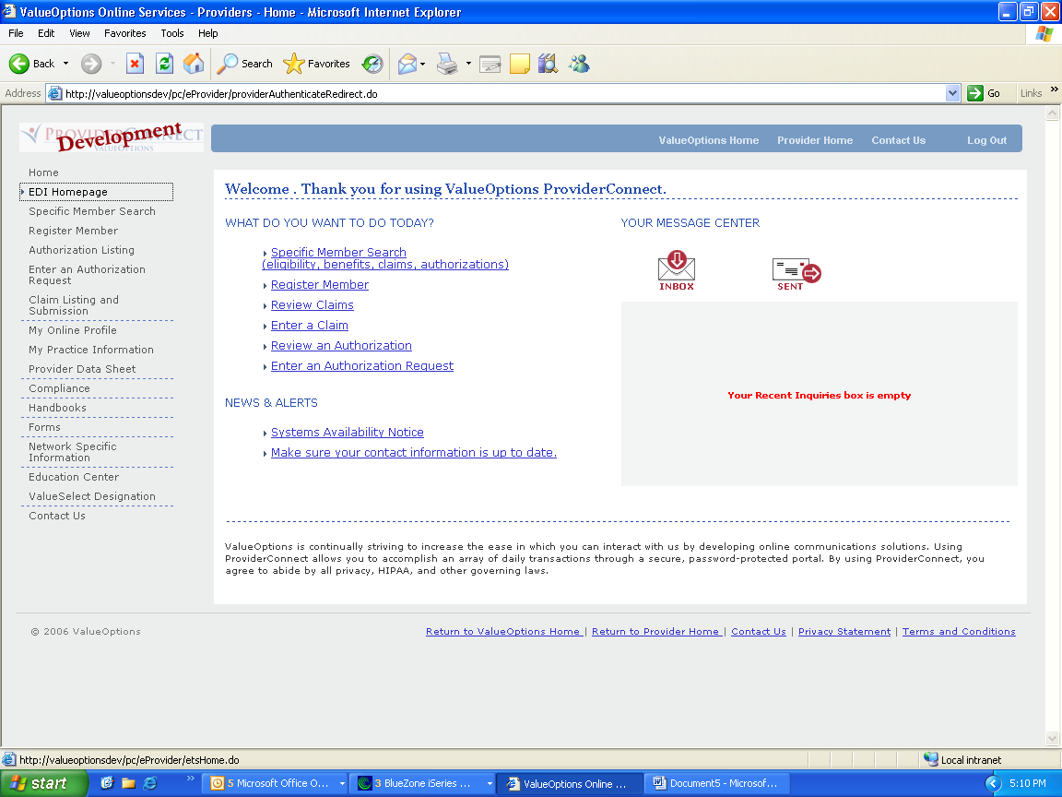

B. Click ‘Submit Batch File’

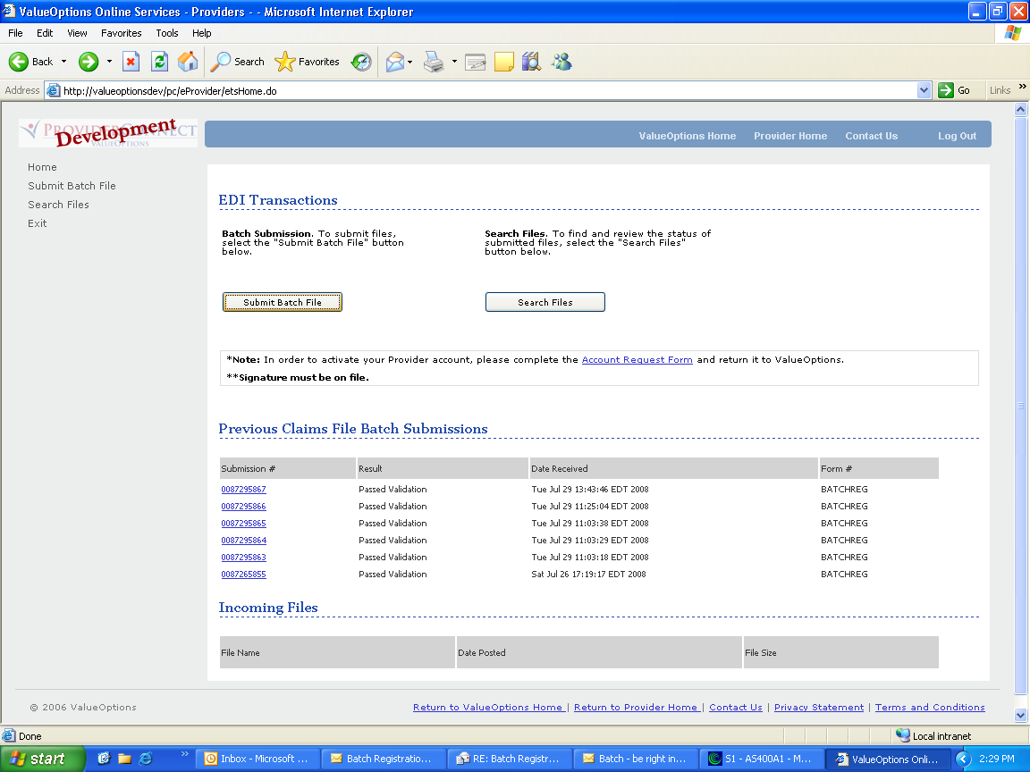

C. Select the ‘BATCHREG’ form type and click ‘Next’

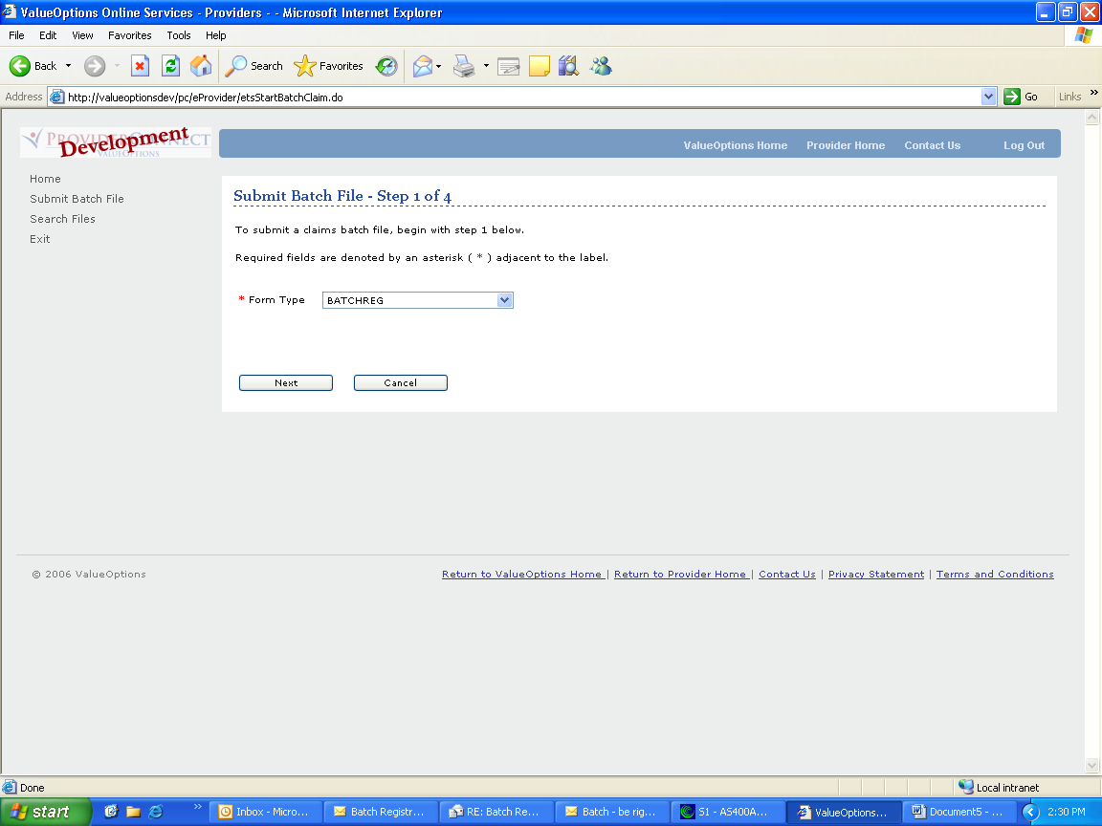

D. Click ‘Next’

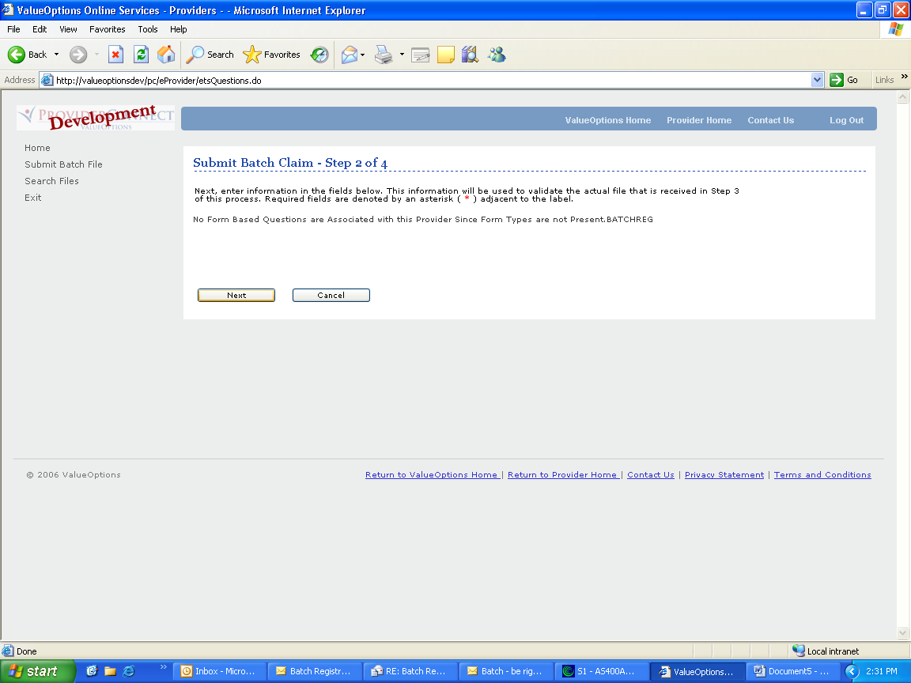

D. Click ‘Browse’ and attach the file. Once attached click ‘Submit’

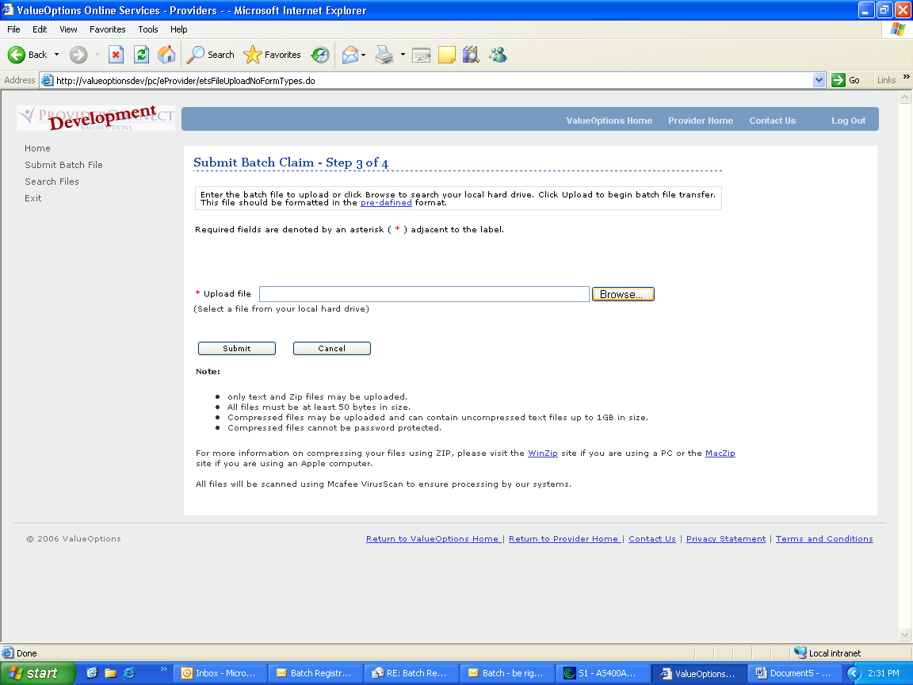

E. The below message will display indicating that the file was submitted successfully and that the email recipient attached to the account will receive an email with the file submission number.

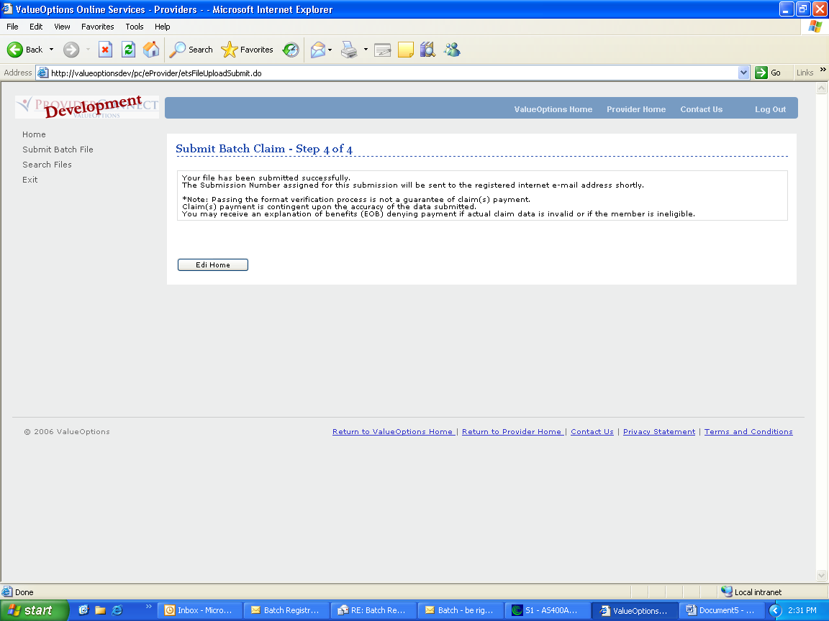

Two emails will be generated once the file has been submitted. Example emails below. Please note the submission number that has been assigned to the batch registration as this submission number will be used on the response files.

First email:

-----Original Message-----
From: ets@valueoptions.com [mailto:ets@valueoptions.com]
Sent: Friday, August 29, 2008 12:35 PM
To: Provider, Illinois
Subject: EDI Submission Number

Your EDI File was successfully received from submitter 123456. The Submission ID is: 0088296061

Second Email:

-----Original Message-----
From: e-supportservices@valueoptions.com [mailto:e-supportservices@valueoptions.com]
Sent: Friday, August 29, 2008 12:35 PM
To: Provider, Illinois
Subject: EDI File Outcome

Your EDI File 0088296061 was successfully received from submitter 123456 and has passed initial validation. Once it has passed any additional validation needed, it will be transferred to the backend server for processing. Thank you for your submission!

FILE ERRORS

There are several conditions when met will cause the entire file to be rejected.

- If the file format is incorrect – error message will be ‘INVALID FILE FORMAT’

- If there is no trailer record – error message will be ‘NO TRAILER RECORD’

- If the trailer record position 11 is not numeric – error message will be ‘TOTAL NUMBER OF RECORDS NOT NUMERIC’

- If the number in the trailer record does not equal the number of registration records - error message will be ‘TOTAL NUMBER OF RECORDS NOT EQUAL TO TRAILER RECORD’

If any of the above conditions are met then a response file will be generated which will contain one record with the applicable error message indicated above.

The file name will be the submission number with the first zero replaced with ‘#’ and an ‘R’ suffix.

Example:

Submission Number – 0088252927

Response file - #088252927R

RESPONSE FILES

There could be up to three response files sent for each batch registration file if the registration file was not rejected. The file name will be the submission number with the first zero replaced with ‘#’ and a one character suffix added.

- Summary File – ‘R’ suffix (If the file was rejected this is the only response file that will be sent for that submission)
- Accepted File - ‘A’ suffix
- Error File - ‘E’ suffix

Example: Submission Number – 0088252928

Summary file - #088252928R
Accepted file - #088252928A
Error file - #088252928E

The summary (‘R’) file will always be sent. The accepted and error file will be generated if there are registration records that are being reported on those files. For example if all the records were successfully loaded and there were no rejected records than the summary (R’) file and the accepted (’A’) file will be generated. The error (‘E’) file will not be generated.

Summary File

The summary file will indicate if the registration record was accepted or rejected (error). The file layout will be the input file with the following fields added to the end of each registration record.

Position  From | Position  To | Length | Field name | Description
915 | 915 | 1 | Williams Class Consumer Indicator | Required: Field = Y or N
916 | 922 | 7 | IMD Home Code | Required if Williams Class Consumer Indicator = Y
923 | 923 | 1 | Upload Status | This indicates the status of this registration record  Valid values:  0 = accepted  1 = rejected
924 | 924 | 1 | Registration Status | Will only be present for records that have an upload status of ‘0’  Valid values:  A = Approved

The Trailer record submitted will be included and 2 additional records will be added to the end of the file. One record will report the number of accepted registrations and one record will report the number of rejected registrations.

Position  From | Position  To | Length | Field name | Description
1 | 10 | 10 | Accepted | Will always be ‘Accepted’
11 | 25 | 15 | Total | Total number of registration records accepted in this batch submission

Position  From | Position  To | Length | Field name | Description
1 | 10 | 10 | Rejected | Will always be ‘Rejected’
11 | 25 | 15 | Total | Total number of registration records in error in this batch submission

Accepted File

The accepted file will contain all registration records that were accepted.

On a transaction of an ‘R’ it will report all programs the consumer was enrolled in for that registration with the effective and expiration date for the fund and the status of all special programs requested.

On a transaction of a ‘C’ it will report all programs the consumer registration closed with the effective and expiration date for the fund and the status of all special programs requested.

On a transaction of a ‘D’ it will report one record with fund and the effective and expiration dates blank and the comment – ‘Address Only Update Record submitted – Address has been updated’.

The file format will be the input file with the fields added to the end of the record to indicate the fund, effective date, expiration date and a comment, where applicable.

The registration record will be repeated for each fund the consumer was enrolled in or closed. For example if the consumer was enrolled in 3 funds then the registration record will be repeated 3 times.

As of 4/25/09 two new messages have been added to the accepted reports. The messages are a reminder that if an authorization is required for the services being rendered to the consumer the authorization must be requested within 30 days of the registration. The authorization will be pre-populated with the following information from the registration.

- AXIS I Diagnosis Code 1
- AXIS I, Diagnosis Code 2
- AXIS I, Diagnosis Code 3
- AXIS II, Diagnosis Code 1
- AXIS II, Diagnosis Code 2
- AXIS II, Diagnosis Code 3

- GAF Score or CGAS Score

- LOCUS Results
  - Risk of Harm
  - Recovery Environmental – Environmental Stressors
  - Recovery Environmental – Environmental Support
  - Functional Status
  - Co-morbidity
  - Recovery And Treatment History
  - Acceptance and Engagement
  - LOCUS Recommended Level of Care
  - Assessor Recommended Level of Care
  - Composite Score

- Worker Ohio Problem Severity Scale Score
- Worker Ohio Functionality Scale

If any of the above information entered on the registration has changed then the consumer needs to be re-registered so the authorization will pre-populate with the current information for the consumer.

If the consumer is being registered in the ABC fund then the following message will appear on the accepted report in the comment field on the ABC fund record: If the consumer requires ACT or CST services an authorization needs to be requested within 30 days.

If the consumer is being registered in the ICG or ICGC fund then the following message will appear on the accepted report in the comment field on the ICG or ICGC fund record: Any required Authorization/Quarterly Review must be submitted within 30 days.

Reporting of Ineligible Consumers:

- When a consumer is determined to be ineligible and this is the initial registration the consumer will be reported with no funds listed. The consumer’s eligibility status will be INEL.

- When a consumer is determined to be ineligible and this is a re-registration all funds from the prior registration will be terminated one day before the re-registration start date. The consumer’s eligibility status will be INEL.

Position  From | Position  To | Length | Field name | Description
915 | 915 | 1 | Williams Class Consumer Indicator | Required: Field = Y or N
916 | 922 | 7 | IMD Home Code | Required if Williams Class Consumer Indicator = Y
923 | 923 | 1 | Upload Status | This indicates the status of this registration record  Valid values are:  0 = accepted
924 | 924 | 1 | Registration Status | All records will have ‘A’.  Valid values are:  A = Approved
925 | 928 | 4 | Program Code | Core or Special Program Code
929 | 936 | 8 | Effective Date | Date on which the consumer became eligible for the program
937 | 944 | 8 | Expiration Date | Date by which the consumer will need to be re-registered if the consumer is still receiving services
945 | 1044 | 100 | Comment | This field will indicate why a specific program requested was not accepted.  This field will also contain a reminder message concerning authorizations for specific programs.

Error File

The error file will contain all registration records that were rejected. If there is a critical error encountered only the critical error will be reported. If the record contains a non critical error then the all non critical errors will be reported by repeating the registration record for each error. For example, if the record contains 3 non critical errors then the registration record will be repeated 3 times.

The file format will be the input file with the fields added to the end of the record to indicate the error code and error description.

Position  From | Position  To | Length | Field name | Description
910 | 910 | 1 | Williams Class Consumer Indicator | Required: Field = Y or N
911 | 917 | 7 | IMD Home Code | Required if Williams Class Consumer Indicator = Y
918 | 918 | 1 | Upload Status | This indicates the status of this registration record  Valid values are:  1 = rejected
919 | 919 | 1 | Registration Status | All records will be blank.
920 | 922 | 3 | Error Code | A code assigned that indicates why the record was rejected
923 | 1022 | 100 | Error Description | Description of why the record was rejected

RETREIVING RESPONSE FILES

The response file(s) will be sent to ProviderConnect. This will result in the email recipient receiving email notification(s) that there are files available and ready for download.

If there was a file level error than one email will be sent. If the file was successfully loaded than up to three emails will be sent, one for each response file for that submission.

-----Original Message-----
From: e-supportservices@valueoptions.com [mailto:e-supportservices@valueoptions.com]
Sent: Friday, August 08, 2008 10:55 AM
To: Provider, Illinois
Subject: File Awaiting Download

You are receiving this e-mail because a file is now ready for submitter 123456 to download from Valueoptions #088296061R.txt. Providers may login and pick up their file from the following website:
http://www.valueoptions.com/eprovider
Clients may login and pick up their file from the following website:
http://www.valueoptions.com/eclient

To retrieve the response files:

A. Log into the ProviderConnect application and click the ‘EDI Homepage’ option on the left hand side of the page

- The response files will appear under the heading of ‘Incoming Files’. Click the hyperlink on the files for that submission. If there is only one response file for that submission number then the entire file was rejected. If the entire file was not rejected then there will be up to 3 response files.

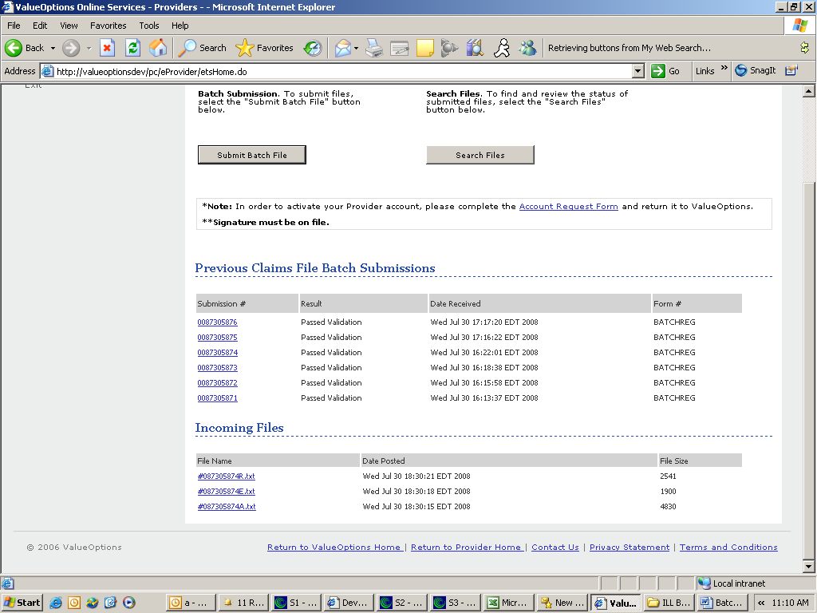

- Click the hyperlink on the file that to download it.

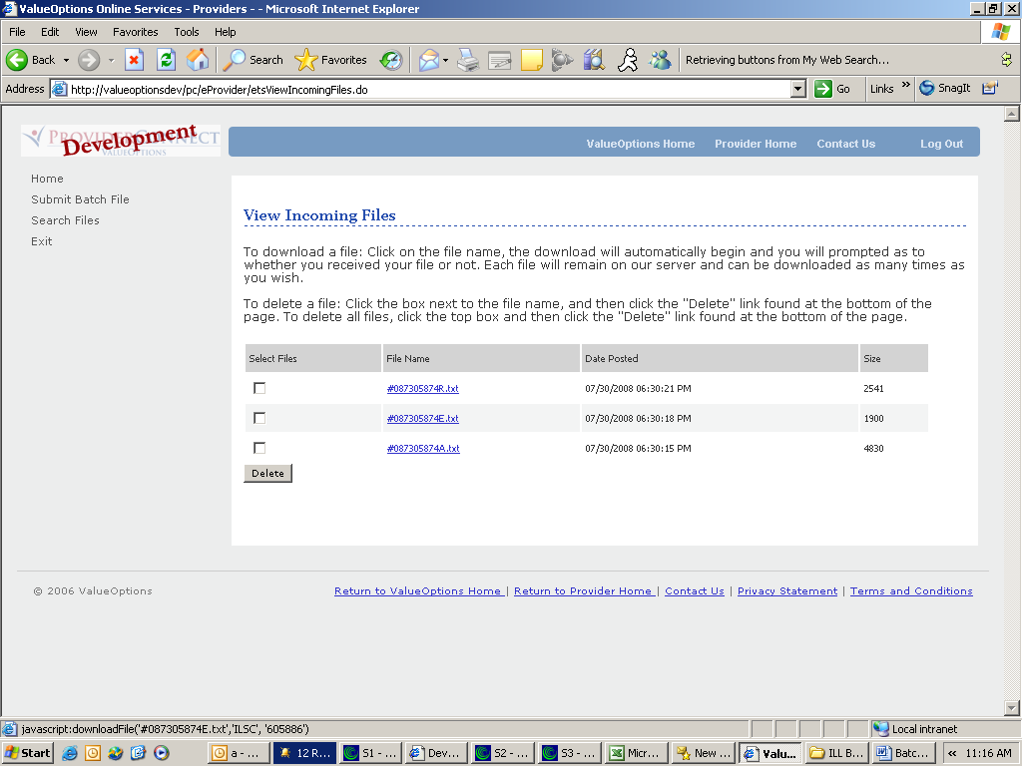

- The below screen will appear asking if the file was downloaded successfully.

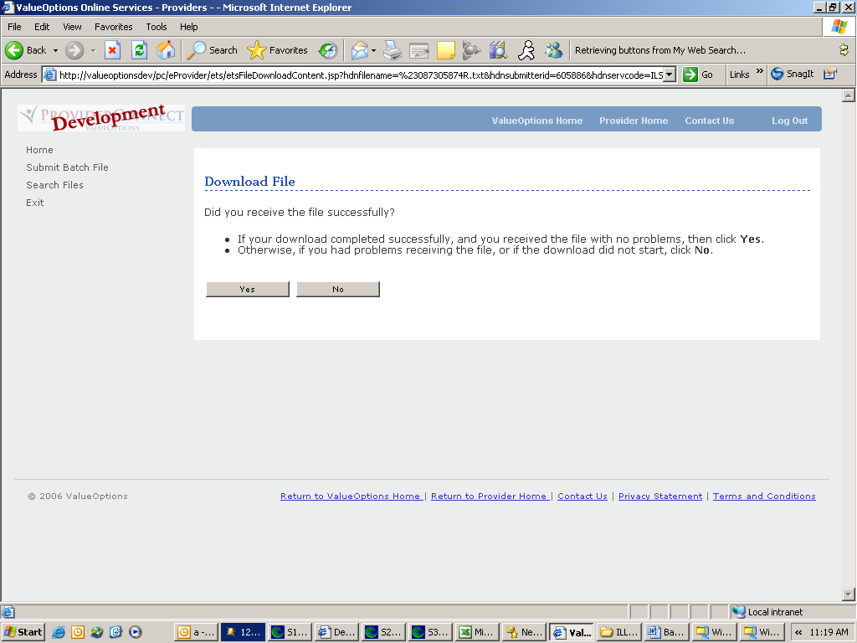

- If the file was downloaded successfully then click Yes then the ‘View Incoming Files’ screen will appear. If the file did not download successfully then select no and the below screen will appear and the download can be tried again or downloaded directly.

